Size 5 ¾”
Double disc, patent Apple 2x17 pins
Size 5 ¼”
- DSSI
- SDI
- MFM -> ST412
- SASI
- ESDI v1
- ESDI v2
- SCSI-I 50
- IDE
- MFM (connector\Interface not edge.) -> ST506
- Lisa patent Apple 2x17 pins
SMD I don't have
ESMD (SMD-E) I don't have
Size 3 ½”
ESDI 72 pins
ESDI 44 pins
ESDI like MFM
MFM -> ST506
IDE\ATA
MFM -> ST412 RLL
JVC unknow
Conner for Apple Hard Disk 40SC 2x17 pins
DSSI
SCSI-I 50
SCSI 68
SCA 80
FC
SSA
SATA gruby
SATA średni fotki wymiary
SATA thin fotki wymiary
SAS
Size ISA 3 ½”
HardCard ISA slot 3 ½”
Size 2 ½”
ESDI
ESDI caddy
SCSI Apple (IBM) 48 pins
IDE
IDE thick

Size 5 ¾” (no ¼”)

5 ¾” Patent Apple 2x17pins ? New World Computer Company INC. Model : Mikro Disc.
This disc consists of two almost identical discs attached to each other at the back.
Connection similar to the proprietary SCSI patent for Apple PowerBook and Lisa.
It has 2 x 17 pins socket. And power socket 6 pins. The situation is identical to the dedicated and proprietary connector in Connor CP-3045 for Apple and Lisa.
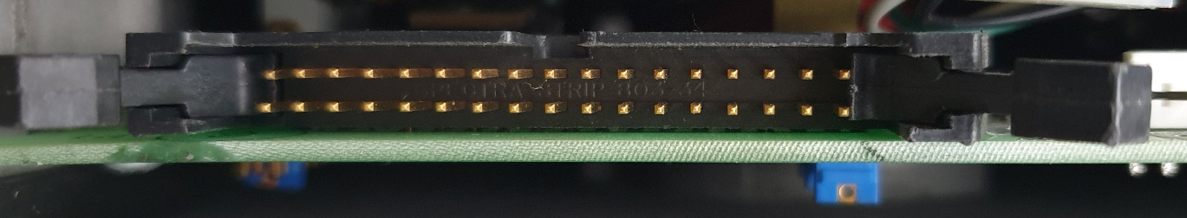
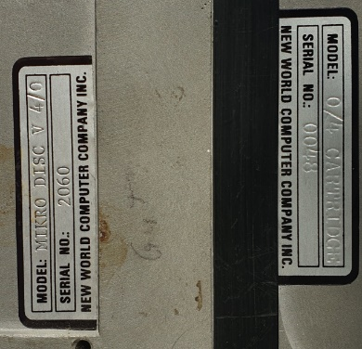
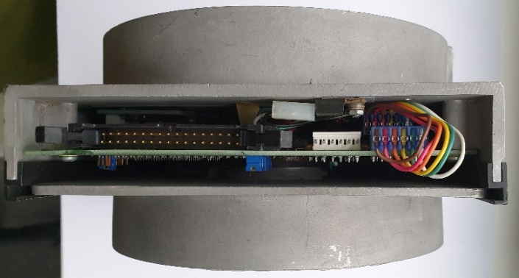

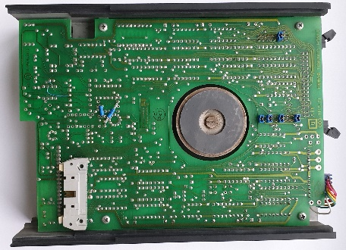
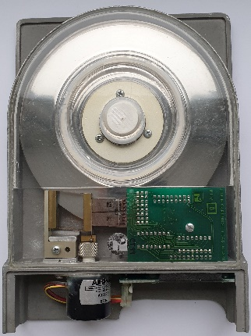
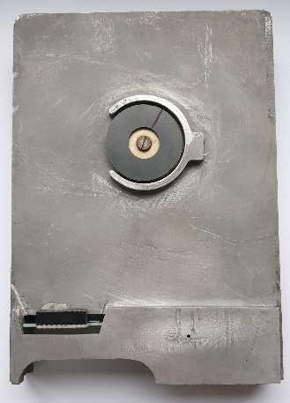
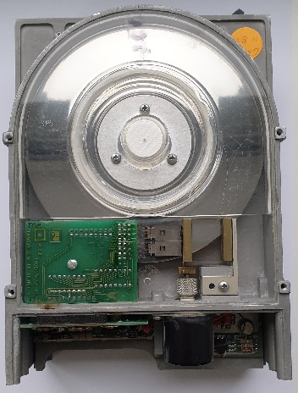
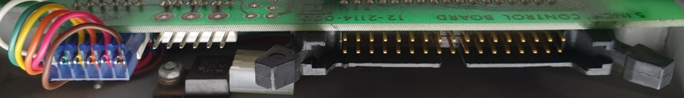

Size 5 ¼”

DSSI
DEC Model RF30 5 ¼” DSSI hard drive. 50 pin connector for data. 5 pin power connector. Data Σ=> 50 pins. DSSI Digital Storage Systems Interconnect. The predecessor of Parallel SCSI, i.e. SCSI-I. A bus for connecting mass storage devices and clustering VAX systems.
https://gunkies.org/wiki/RF30

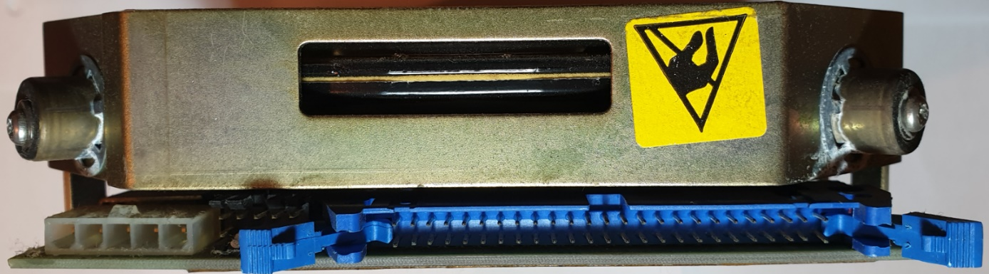
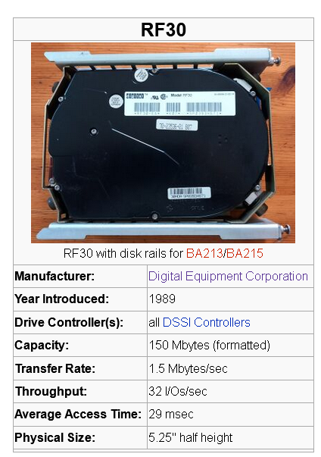
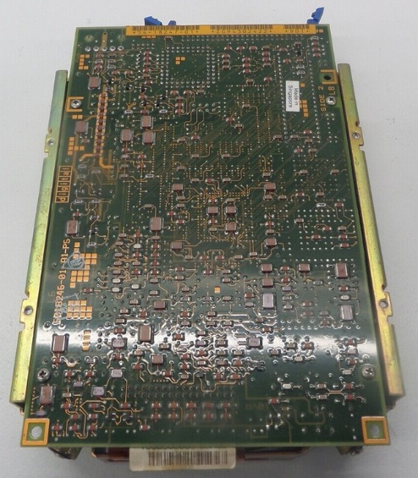

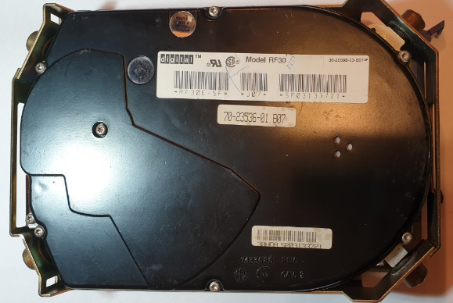

SDI
SDI DEC Model RA70 5 ¼” hard drive. SDI Standard Disk Interconnect. Connector 2x10 + 2x4 +2x4 = 36 pin. Power connector 4 pins.
https://gunkies.org/wiki/RA70_disk_drive

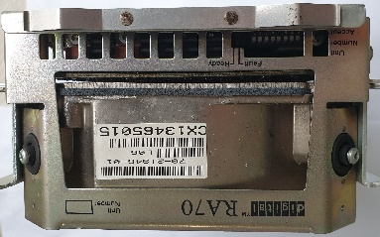
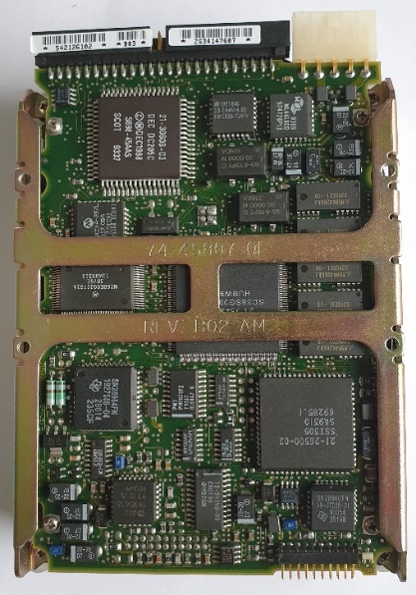
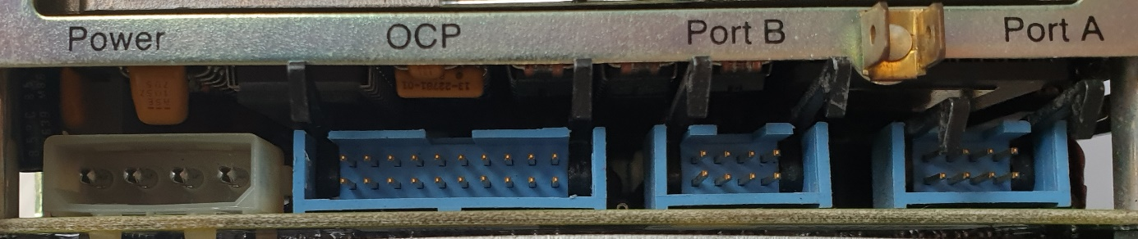
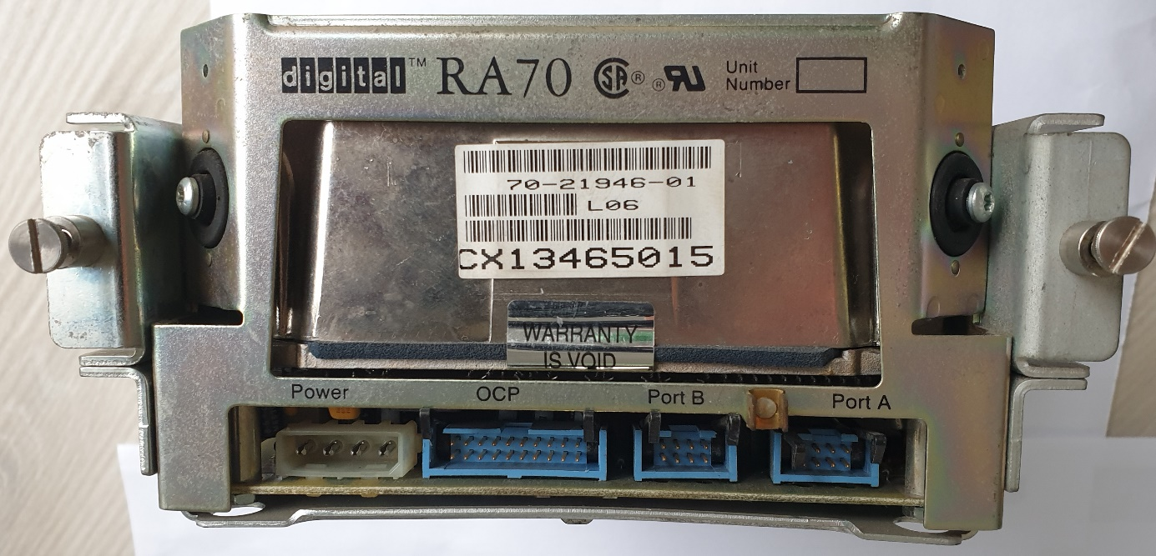

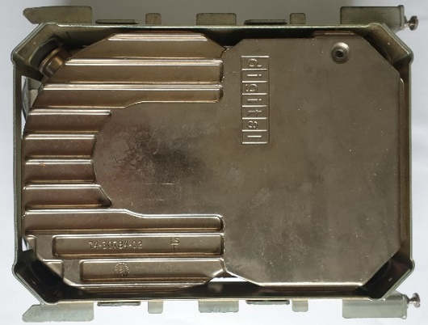

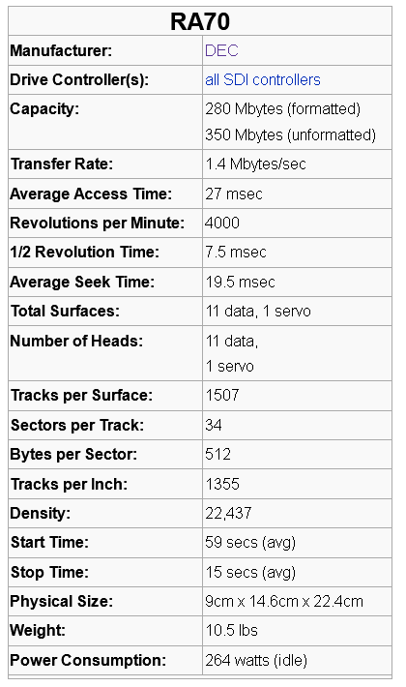

MFM* Type ST412
Hard drive 5 ¼” MFM*, HH with black face, Seagate ST-225. MFM type: ST412. Two connectors: 34 pins for control and 20 pins for data. Σ=> 54 pin. Green diode..
https://stason.org/TULARC/pc/hard-drives-hdd/seagate/ST225-21MB-5-25-HH-MFM-ST412.html
*)The common name of the interface is MFM. The correct name is ST-506 or ST412. Derived from the disk model. It became the standard. There was no such thing as an "RLL disk or MFM disk". The disk type (MFM or RLL) was determined solely by the low-level format, and this in turn depended on the disk controller card. Theoretically, any ST-506 (two-wire) drive can be formatted using an MFM or RLL controller
MFM - Modified Frequency Modulation is the successor FM.
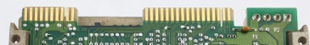
RLL - Run Length Limited.
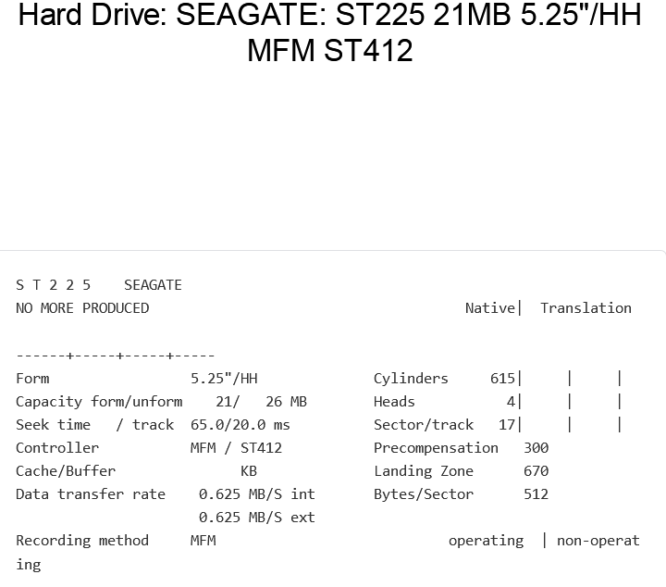
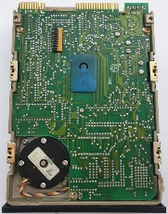
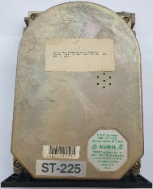

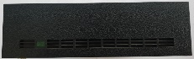

SASI
5 ¼” SASI hard drive, Xebec 4020 installed in Amstrad PC1640\PC1520.
Shugart Associates System Interface. Two connectors: 2x23 + 2x2 pins for data and 4 pins for power. Σ=> 50 pins. Red LED
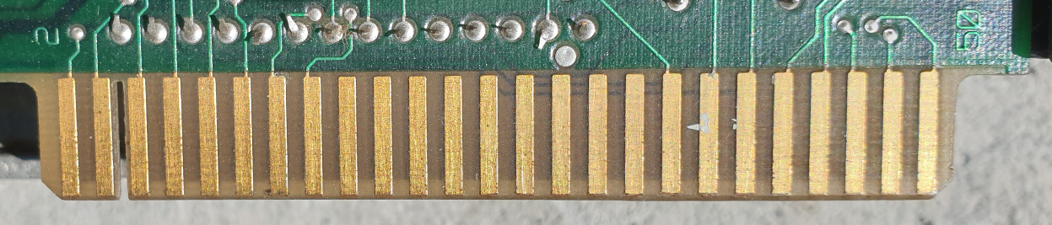

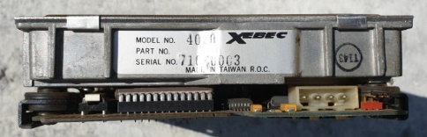
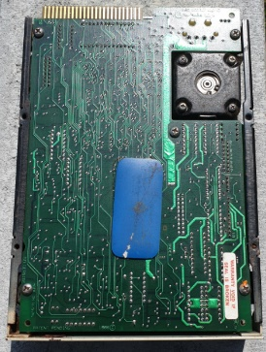
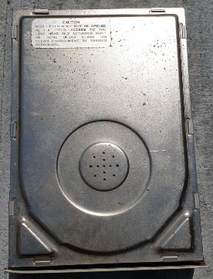

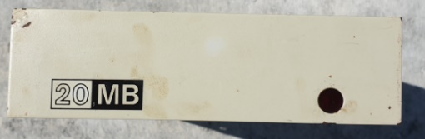

ESDI v1
5 ¼ Micropoli 1568 Full High
2x17 pins + 2x20 pins + 2x4 pins Σ=> 82 pins. Power supply 4 pins.
https://stason.org/TULARC/pc/hard-drives-hdd/micropolis/1568-15-702MB-5-25-FH-ESDI.html

"Enhanced Small Device Interface". It was a hard drive interface standard developed in 1983 by Control Data Corporation. ESDI offered several improvements over the earlier ST506 standard, including:
- Higher data throughput: ESDI could transmit data at up to 10 Mbps, while the ST506 was limited to 5 Mbps.
- Larger disk capacity: ESDI supported disks up to 1 GB, while ST506 supported disks up to 640 MB.
- Improved Reliability: ESDI has introduced several features to improve data reliability, such as error correction coding.
ESDI was a popular hard drive interface standard in the 1980s and early 1990s. However, it was replaced by newer standards such as IDE and SCSI, which offered even higher performance and capacity.

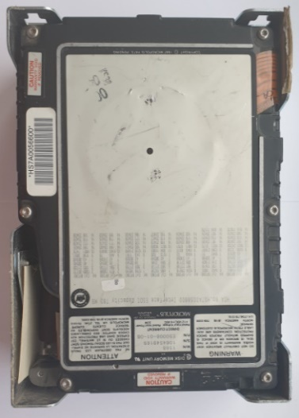
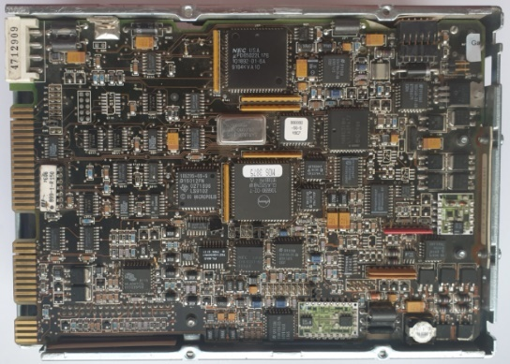
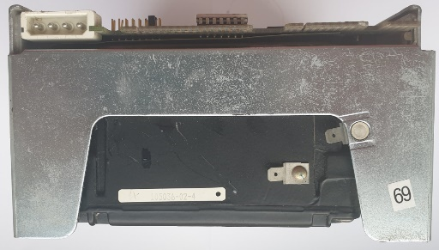
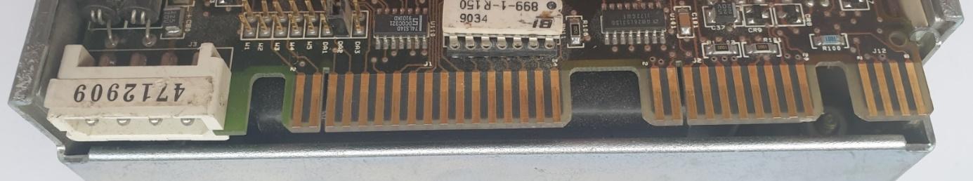

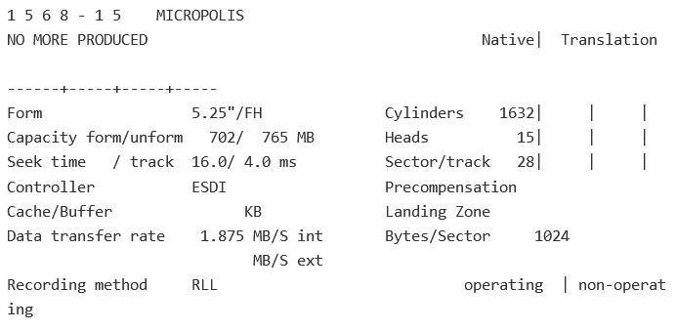

ESDI v2
5 ¼ IBM Type: 0667 90X8528 Full High.
2x17 pins + 2x20 pins (with out 2x4 pins) Σ=> 74 pins. Power supply 4 pins.

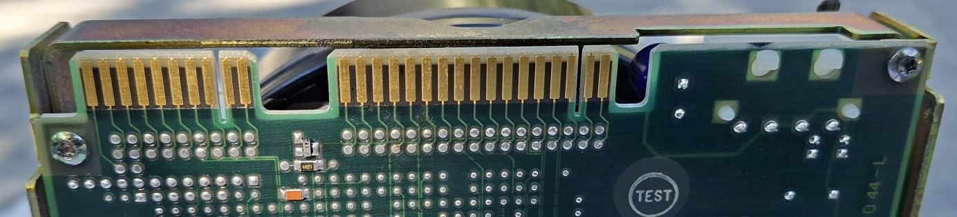
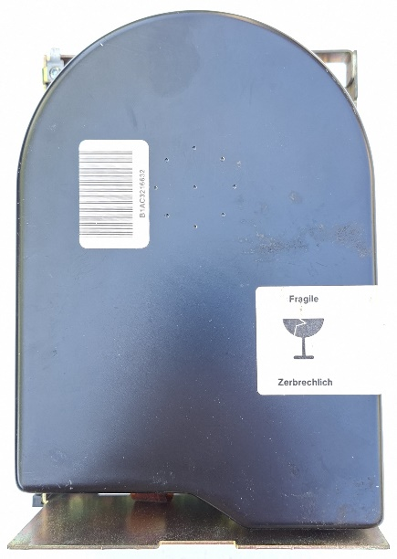
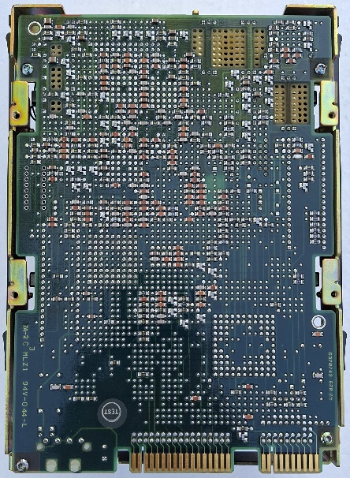

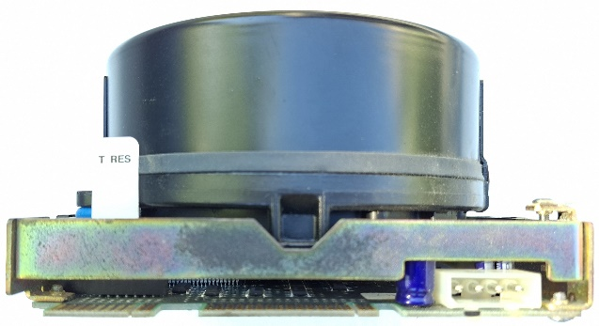
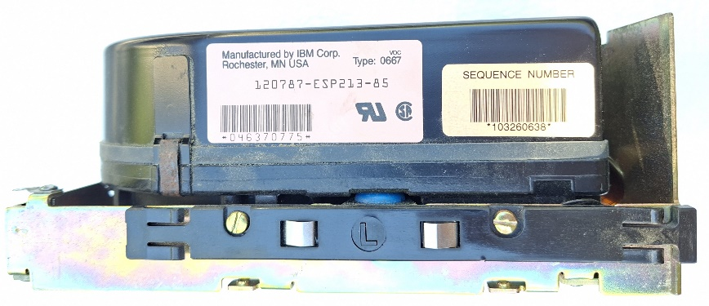

SCSI-I 50 pins
DISK 5 ¼” SCSI 50, FH with black face, Seagate ST4702N. Two cables: 50 pin data and 4 pins for power. Data Σ=> 50 pin. Red LED.
https://stason.org/TULARC/pc/hard-drives-hdd/seagate/ST4702N-WREN-601MB-5-25-FH-SCSI1-SE.html

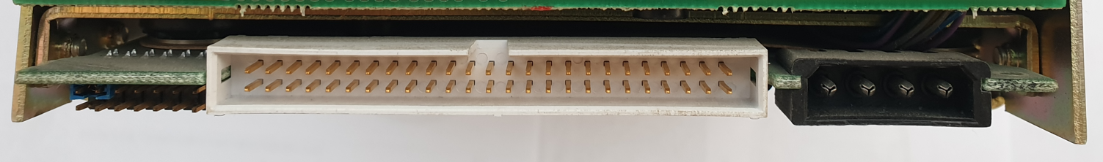
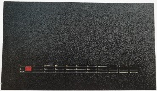
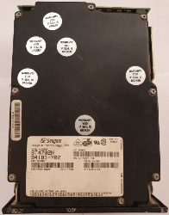
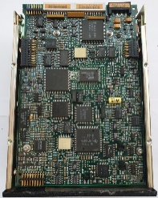

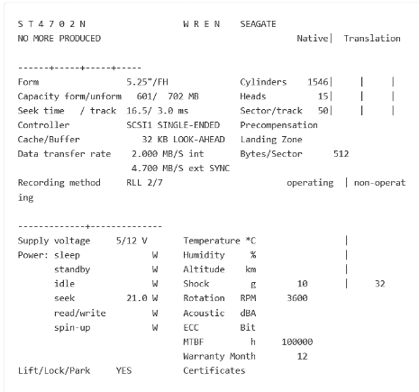

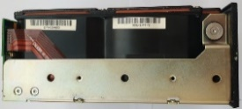
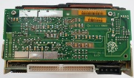

IDE
Disc 5 ¼” Quantum Bigfoot 4320AT.
Two cables: 40 pin data and 4 pin for power. Data Σ=> 40 pin. And jumper pins.

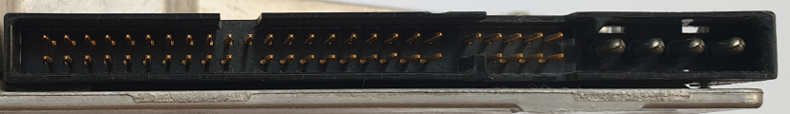
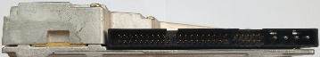

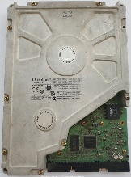
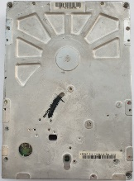

MFM (connector\Interface not edge.)
Disc 5 ¼” MFM, HH with black face, Tandon TM 252. MFM type: ST506. Two cables: 2x10 = 20 pin and 2x17 = 34pin Σ => 54 pin. Red LED. Mounted, for example, in TECMAR together with Q-PAK. The first external drive for Mac.
https://stason.org/TULARC/pc/hard-drives-hdd/tandon/TM252-10MB-5-25-HH-MFM-ST506.html
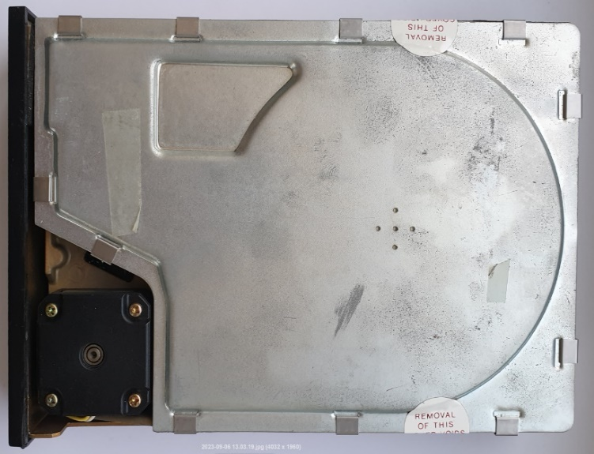
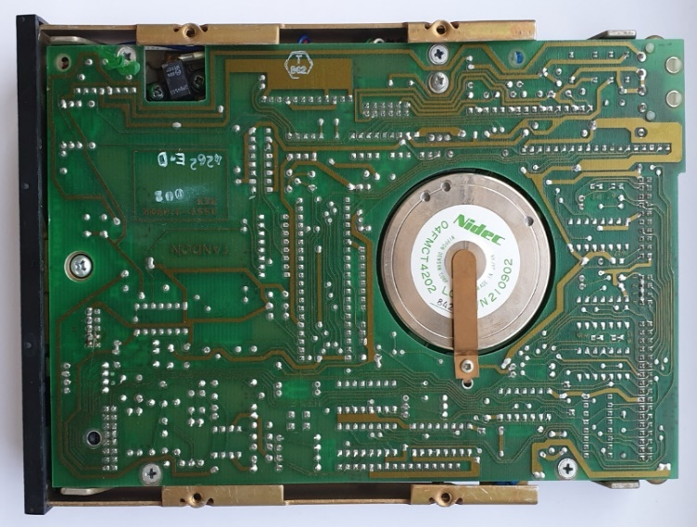
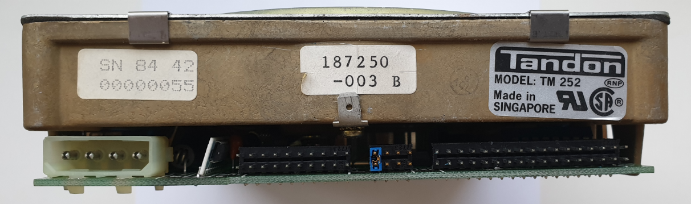

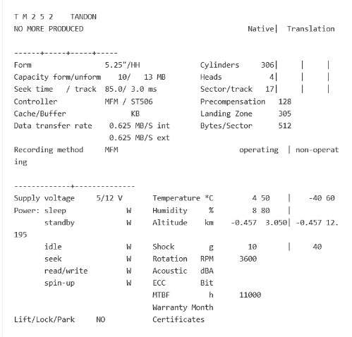
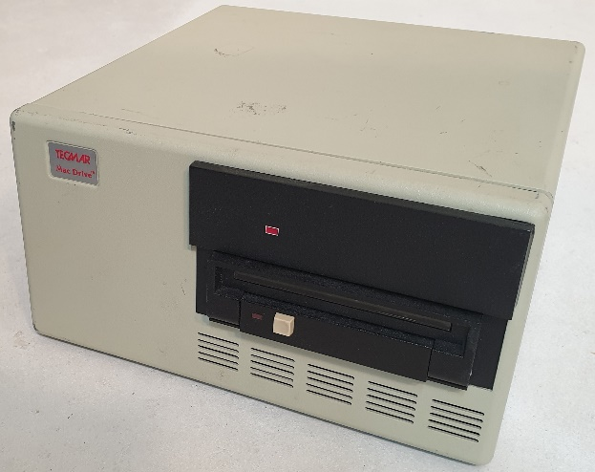

Apple Widget 10 MB 2x17 pins. Patent Apple for Lisa 2 Computer. 1983.
5 ¼” Full High.
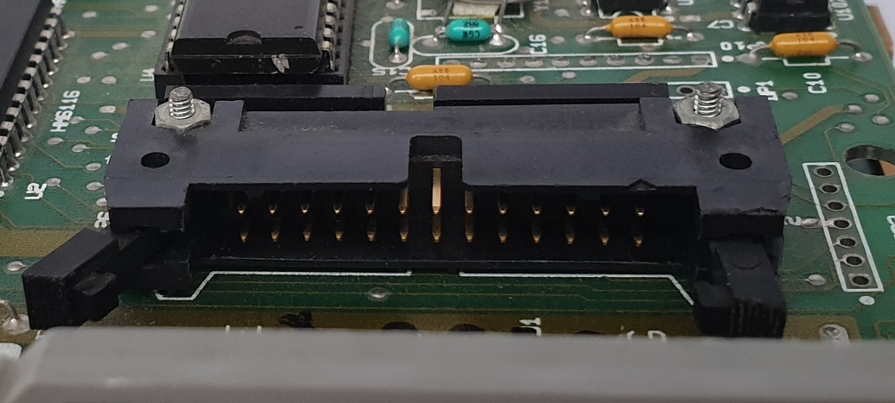

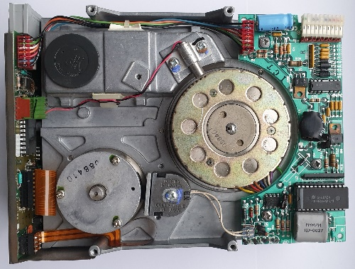
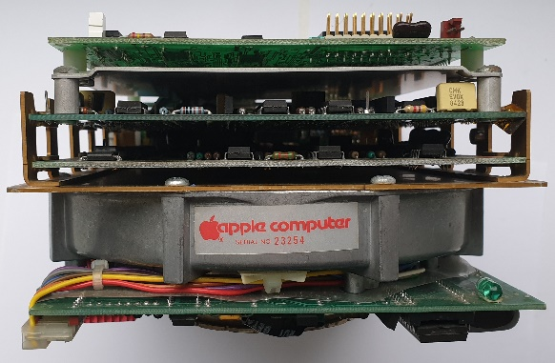

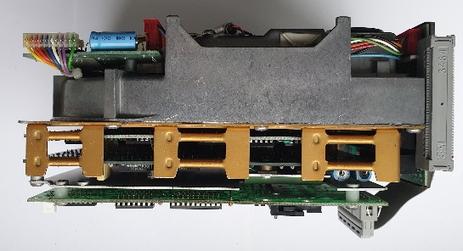
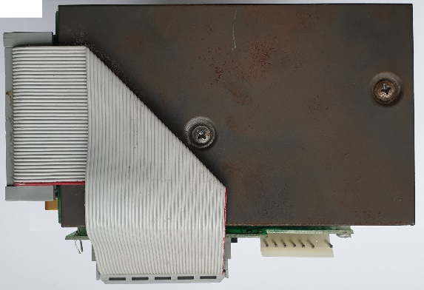

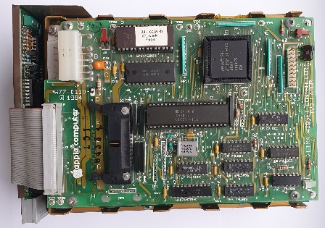
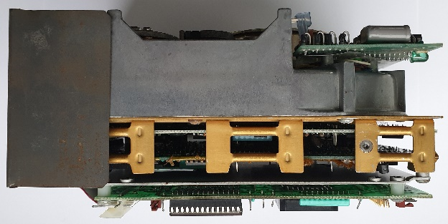

Size 3 ½”

ESDI 72 pins.
3 ½” ESDI HH DISK, HDD from IBM PS. IBM WD-387, PN:6128257 FRU:6128294. 60MB. 2x36 pins. Σ=>72 pins. Yellow LED.
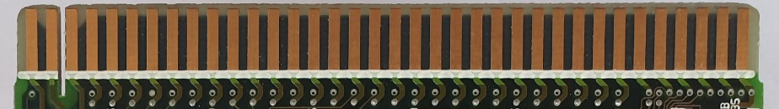
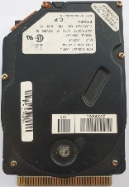
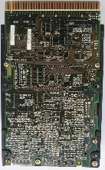
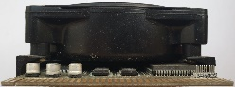
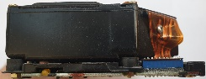

ESDI 44 pins
3 ½” ESDI HDD from IBM PS. WDL-330P, PN:6128242 FRU:6128279. 30MB. 2x22. Σ=> 44 pins. Without diode.
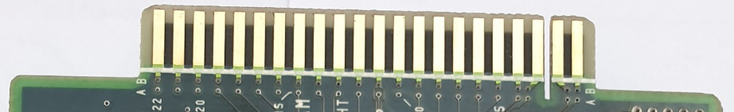
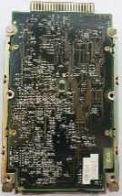
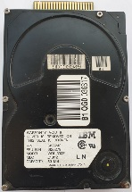

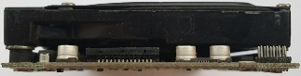

ESDI as MFM
NEC D3661 ESDI HH. Two cables: 2x10 pin + 2x17 pin for power. Separate power supply 4 pins. Σ=> 54 pin.
https://stason.org/TULARC/pc/hard-drives-hdd/nec/D3661-113MB-3-5-HH-ESDI.html

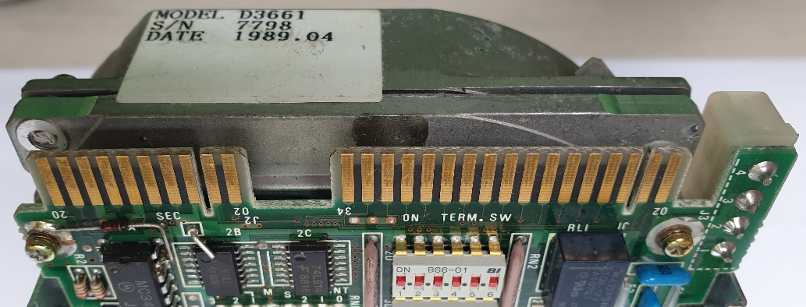

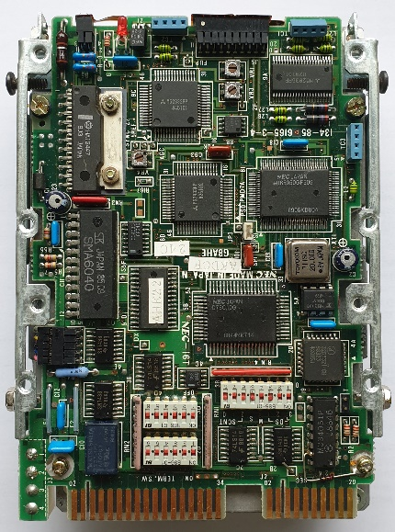
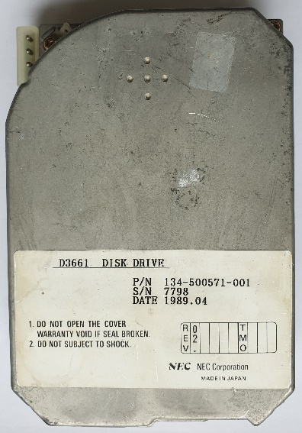

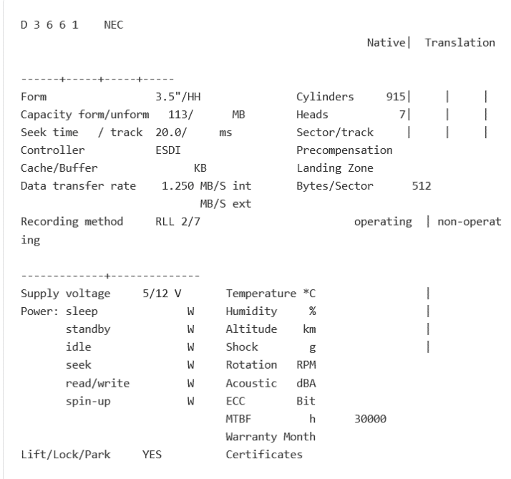
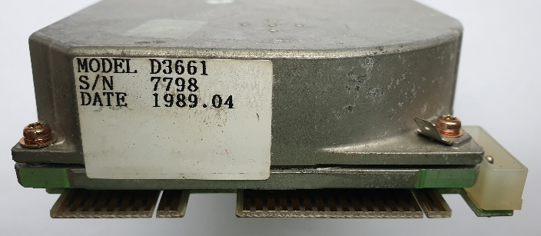

MFM Type ST506
MFM HH Kyocera KC-20B. 21MB. MFM type: ST506. Two cables: 2x10 pin + 2x17 pin for power. Separate power supply 4 pins. Σ=> 54 pin. Green diode.
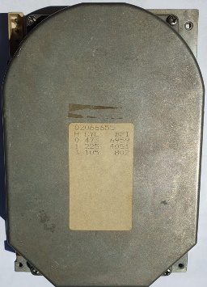
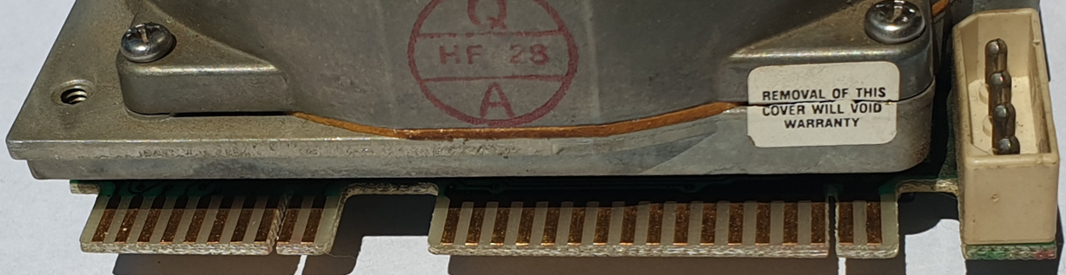
https://stason.org/TULARC/pc/hard-drives-hdd/kyocera/KC-20B-21MB-3-5-HH-MFM-ST506.html
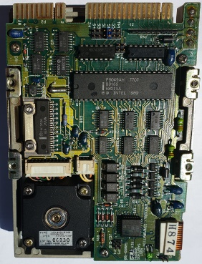
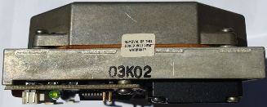

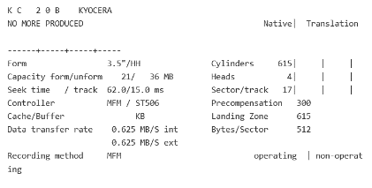

ATA/IDE.
3 ½” ATA/IDE DISK. 40 pins + 9 configuration jumpers. Separate power supply 4 pins. Σ=> 40+9 pins.
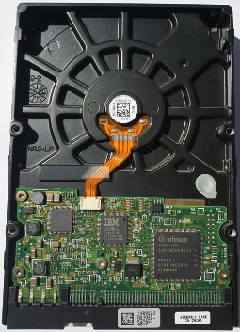
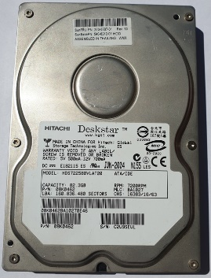

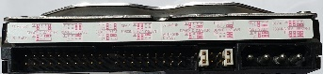

MFM Type ST412 with RLL
3 ½” disc ST-157R Seagate RLL* - Run Length Limited. Type ST412. Two cables: 2x10 pins + 2x17 pin for power. Separate power supply 4 pins. Σ=> 54 pins.
https://stason.org/TULARC/pc/hard-drives-hdd/seagate/ST157R-0-49MB-3-5-HH-RLL-ST412.html
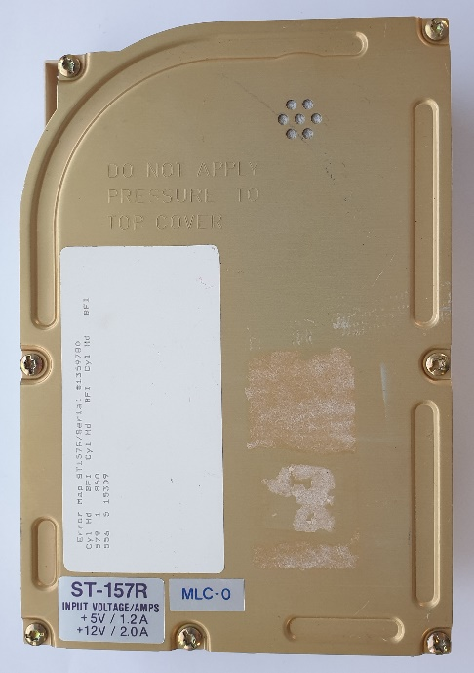
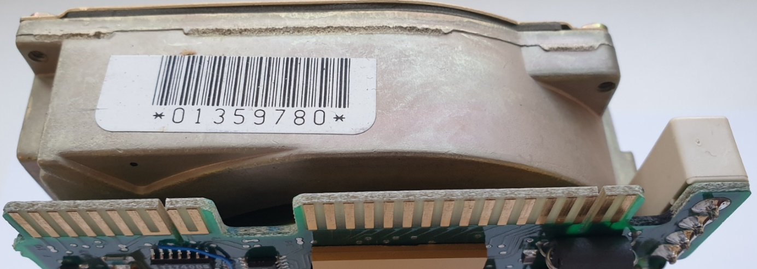
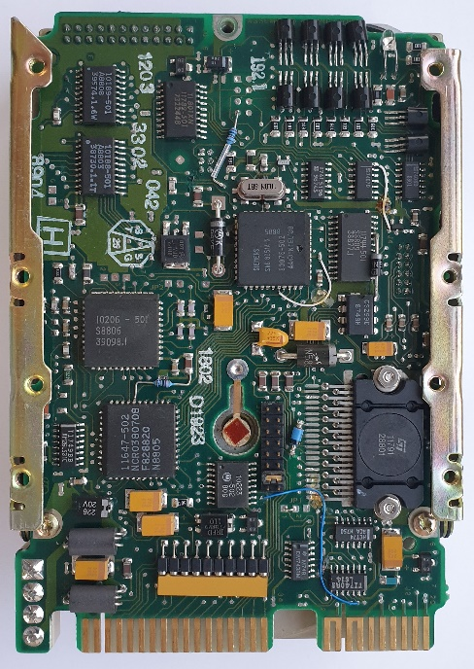

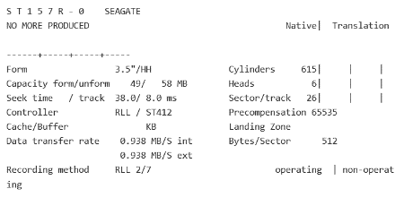

JVC Disc 3 ½” unknow
3 ½” disc. Standard - unknown. JVC JD-3824R00-1. Σ=>26 pins. There are no equivalents \ substitutes \ substitutes. Mounted in Epson PX-16, Epson LT, Epson Q150A, Sharp PC-7200. https://electrickery.nl/comp/divcomp/26pinHD.html

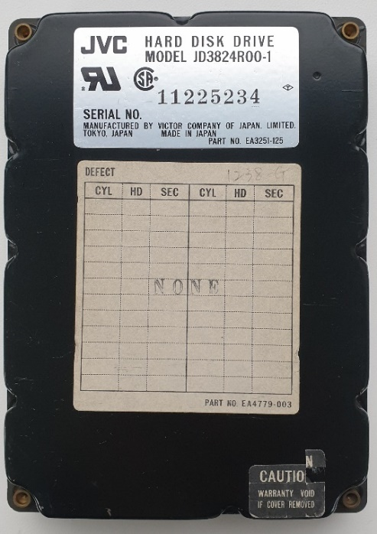
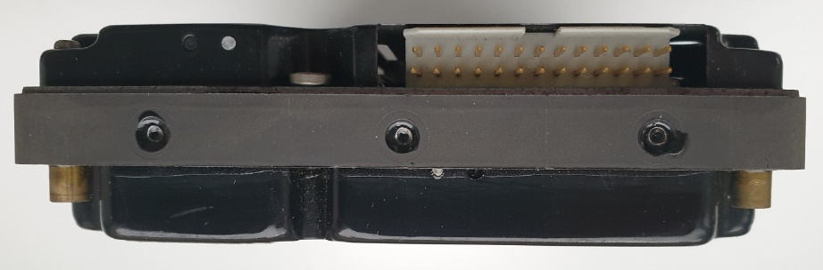
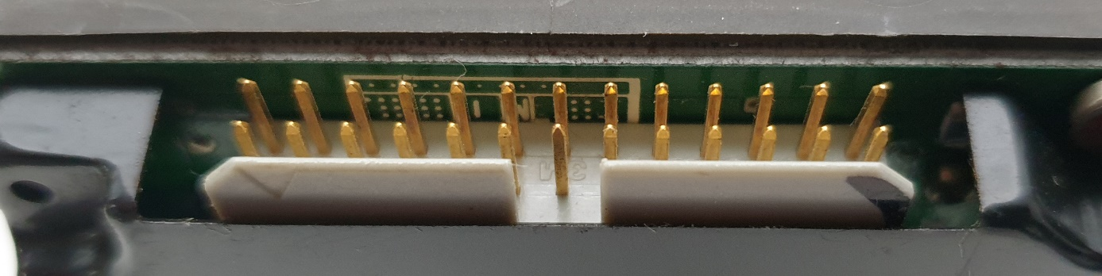
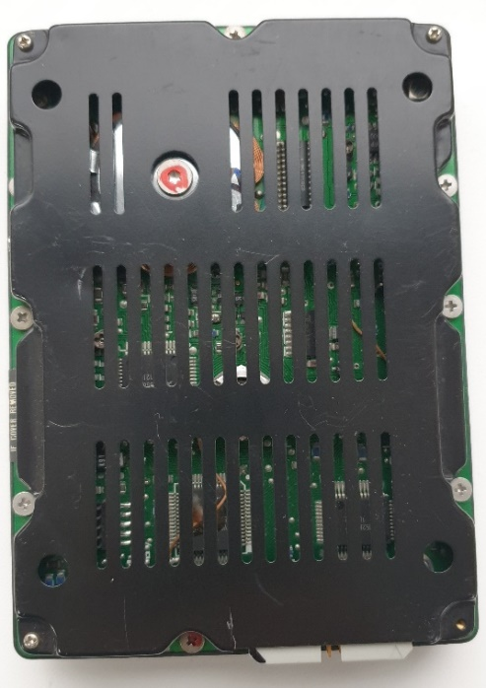

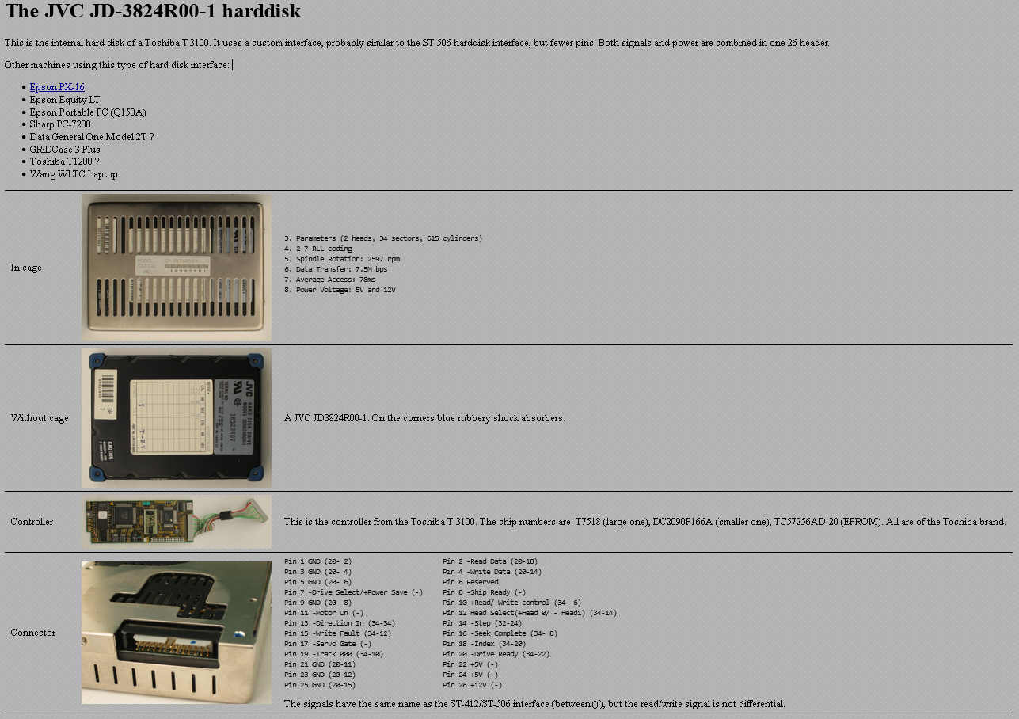

SCSI - patent for Apple 2x17 pins.
Conner CP3045 (Apple Hard disk 40SC)
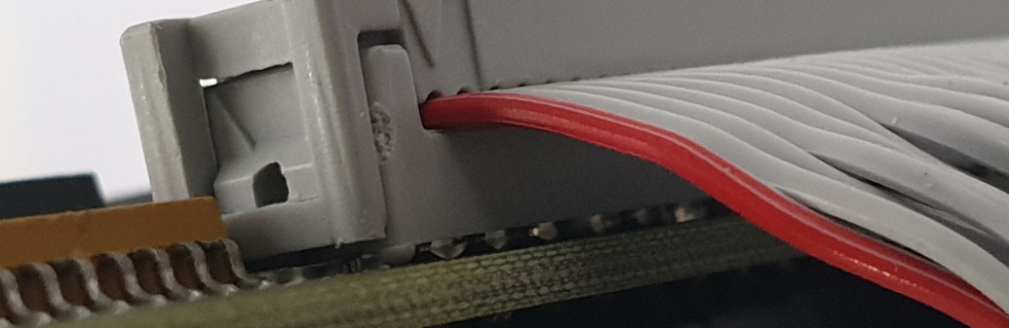
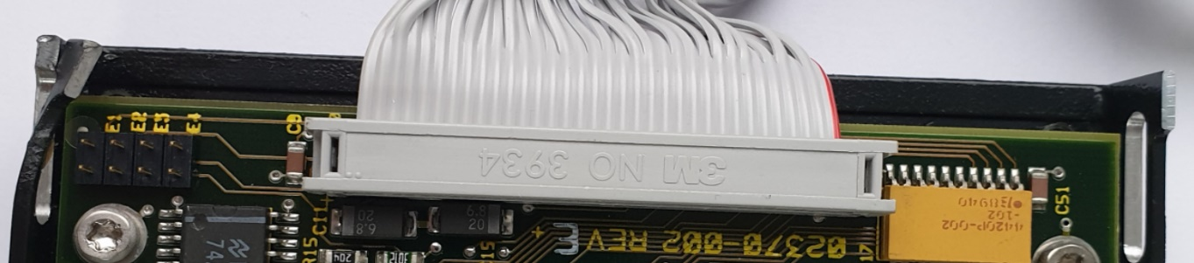
Only 2x17 pins = 34 pins. The connector and number of pins are the same as in the Apple Lisa disk and as in the “strange” disk 5 ¾”. A drive designed specifically for Apple PowerBook. Known by Apple as "Hard Disk 40SC". It has a patented SCSI connector. The cable is permanently connected to the disk. There is no power socket. Only 2x17 pins cable. SCSI patent for Apple.

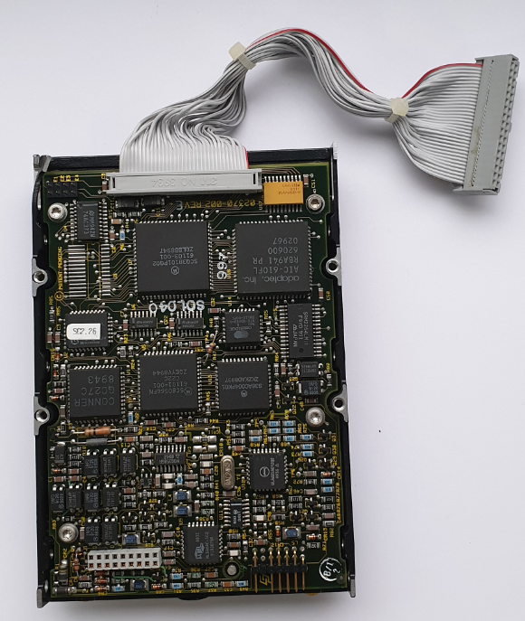
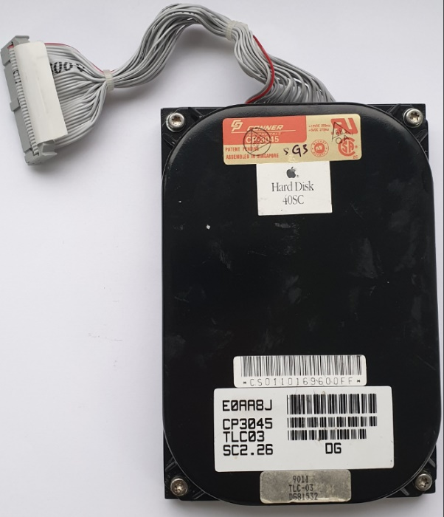

DSSI
DEC Model RF35 3½” Data 2x25=50 pins. Power 5 pins. Data Σ=> 50 pin.
DSSI Digital Storage Systems Interconnect.
https://gunkies.org/wiki/RF35

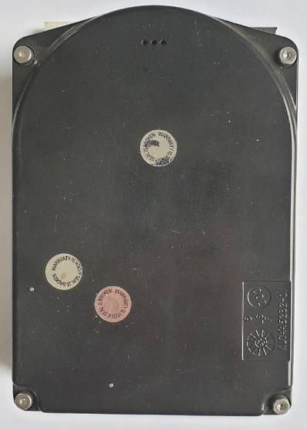
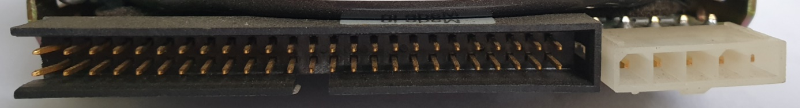
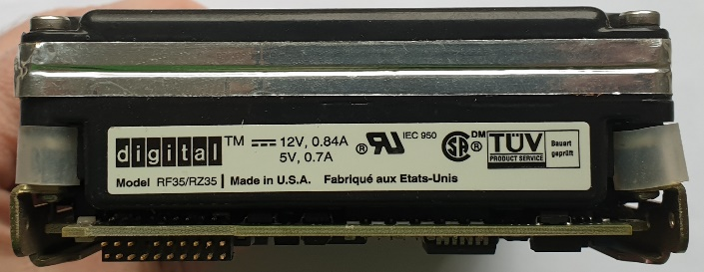
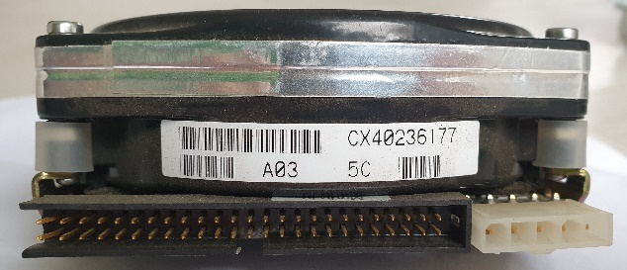
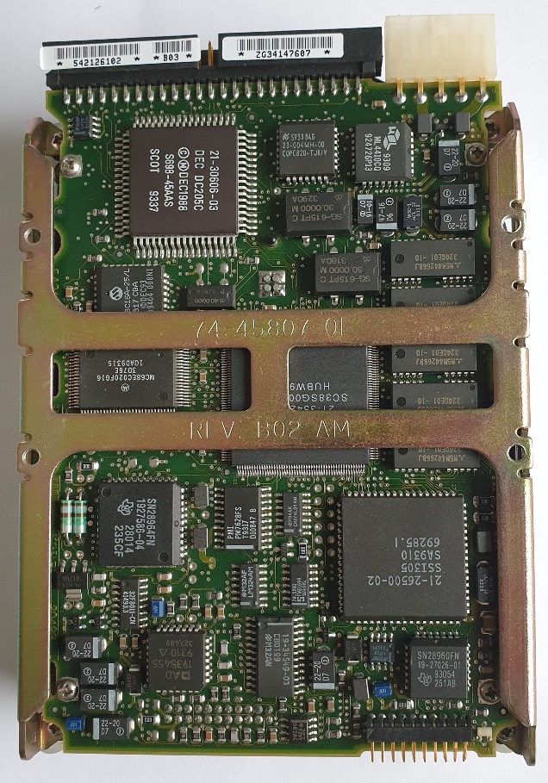

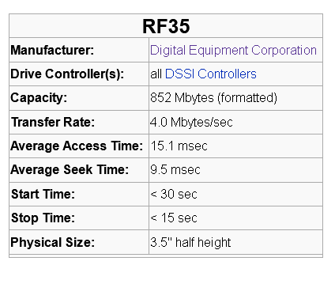

SCSI-I 50 pins.
Quantum Fireball ST. 2x25 pins. Power 4 pins. Σ=> 50 pins.

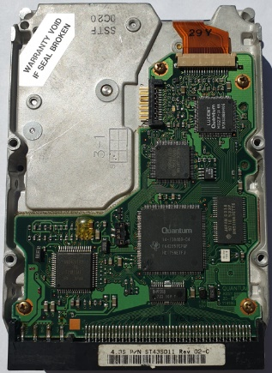
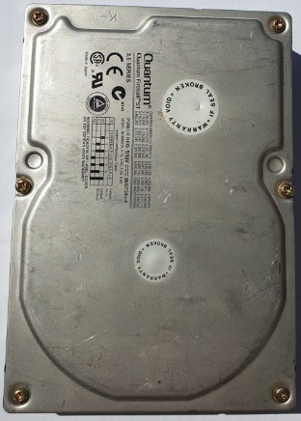
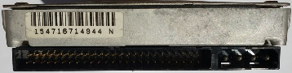

SCSI 68 pins.
3 ½” SCSI 68 Quantum Viking disc. 2x20 pins. 2x6 pins configuration jumpers. Power supply separately 4 pins. Σ=> 40 + 12 pins.
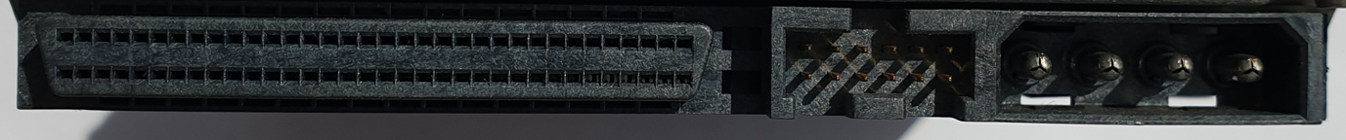
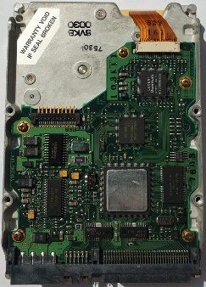
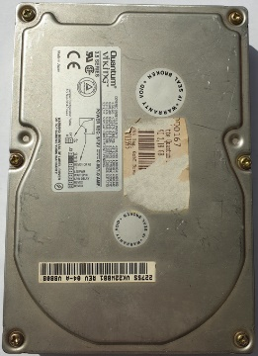

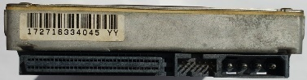

SCA - UltraSCSI 3 80 pins. Single Connector Attachment.
3 ½” SCA drive = Ultra 3 SCSI 80 IBM Ultrastar. 2x40 pins. Σ=> 80 pins.
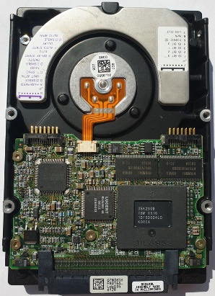
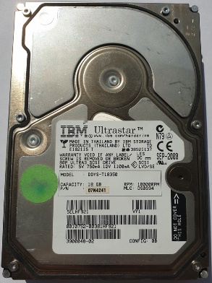

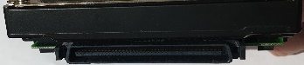

FC Fibre Channel.
Seagate Cheetah.Pins 2x20 Σ=> 40 pin.

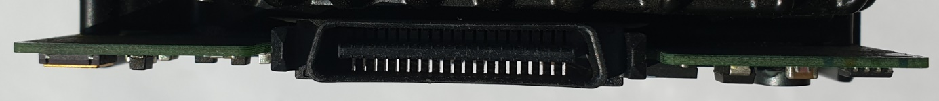
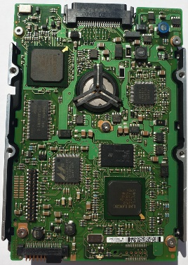
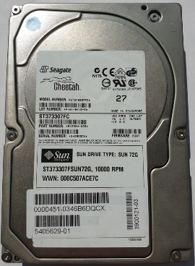
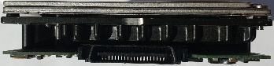

SSA (Serial Storage Architecture)
Drive 3 ½” Pins : 2x3 + 2x3 + 2x5 + 2x8 = Σ=> 38 pins.
and on the other side 2x16 pins.
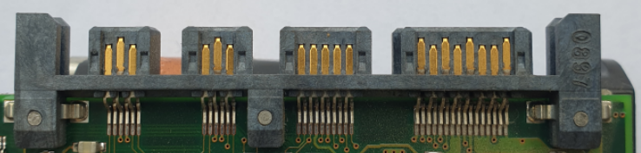
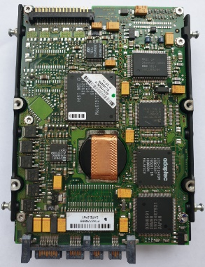
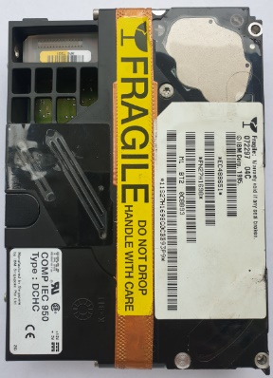
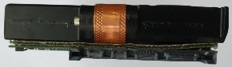

SATA Serial ATA.
Drive 3 ½” Pins : 15 + 7 + 9 jumpers + 4 pins for power.
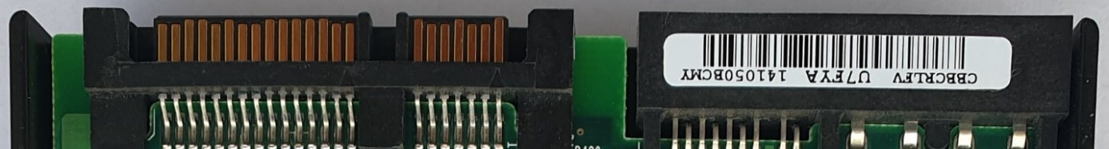
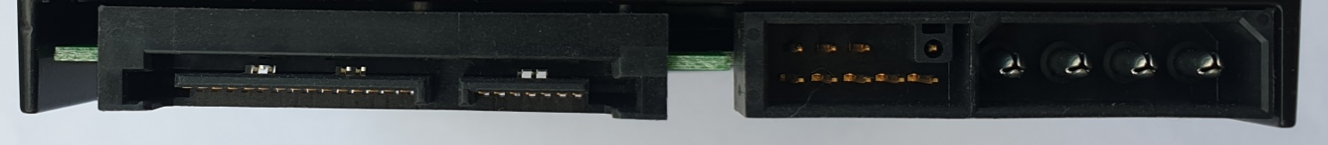
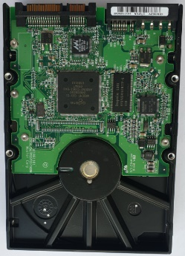
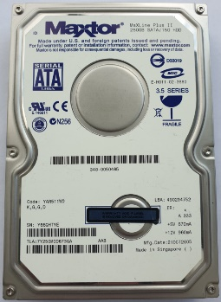

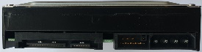

SATA Serial ATA.
Drive 3 ½” Pins : 15 + 7 + 9 jumpers + 4 pins for power.
Low profile. Thickness = 2 cm.
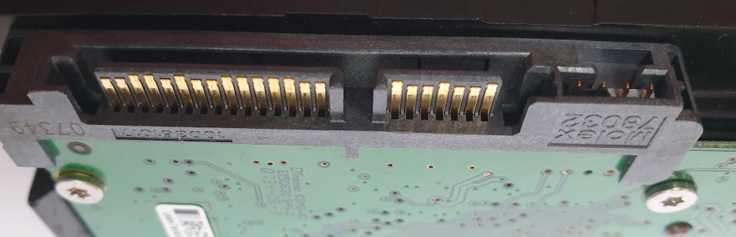

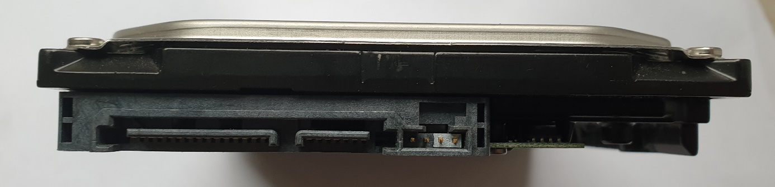
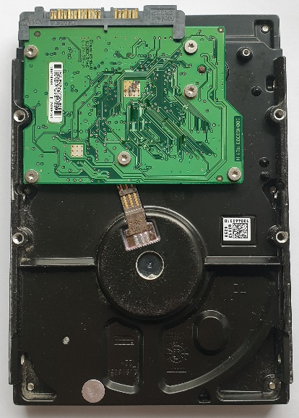
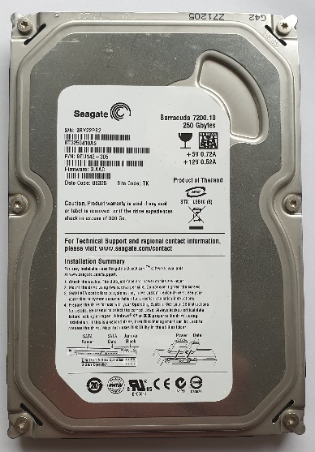

SAS Serial Attached Storage.
Drive 3 ½” Pins : 15 + 7 + 4 jumpers.
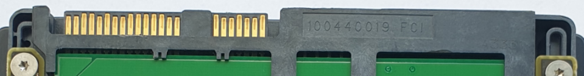
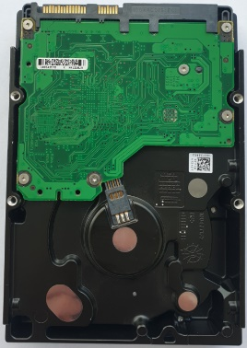
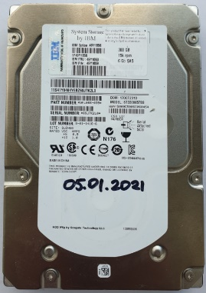

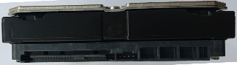


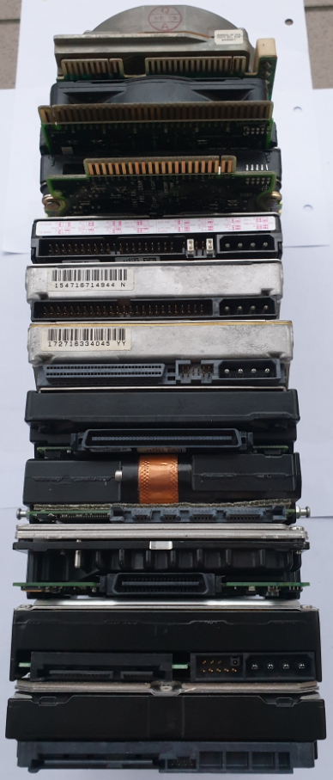

- MFM ST-412

- ESDI IBM PS/2

- MFM IBM ST-506

- IDE \ EIDE

- SCSI 50

- SCSI 68

- SCSI 80

- SSA

- FC

- SATA

- SAS

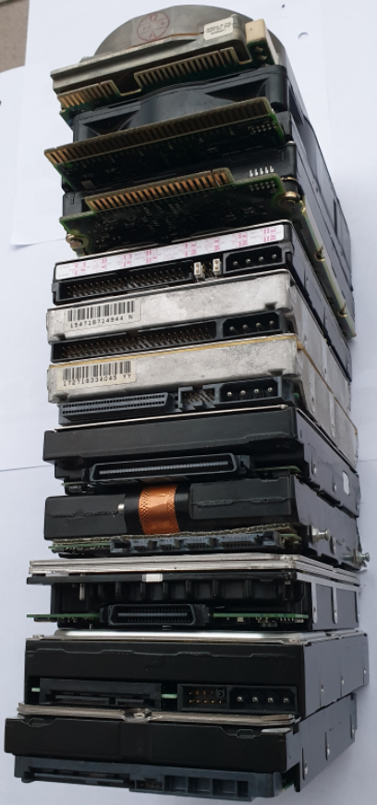
- MFM ST-412

- ESDI IBM PS/2

- MFM IBM ST-506

- IDE/ATA

- SCSI 50

- SCSI 68

- SCSI 80

- SSA

- FC

- SATA

- SAS

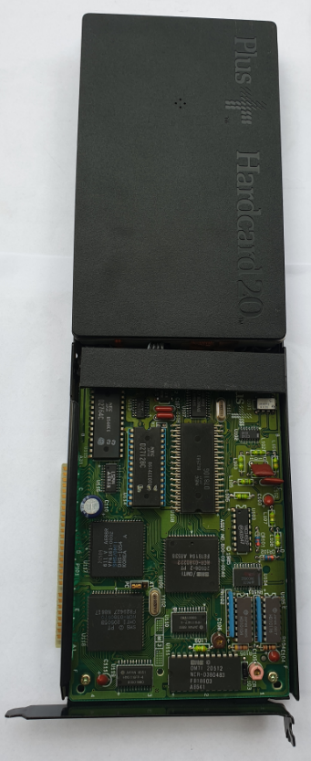
Size 3 ½” ISA

Drive 3 ½” ISA Slot, HardCard 20 PLUS. That is, the disk on the ISA card. Industry Standard Architecture.
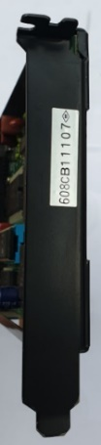
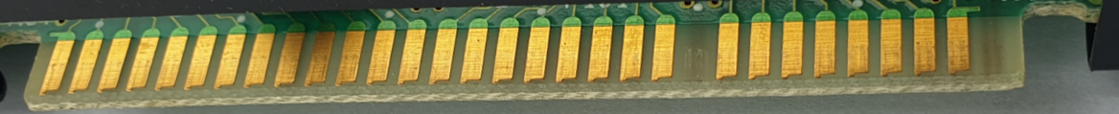
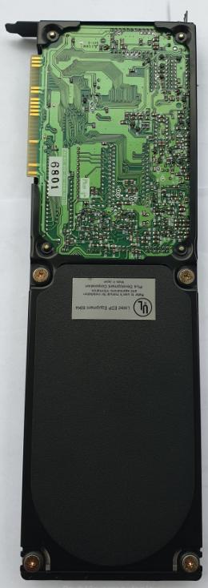

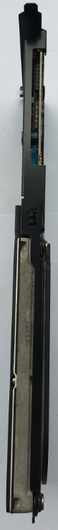

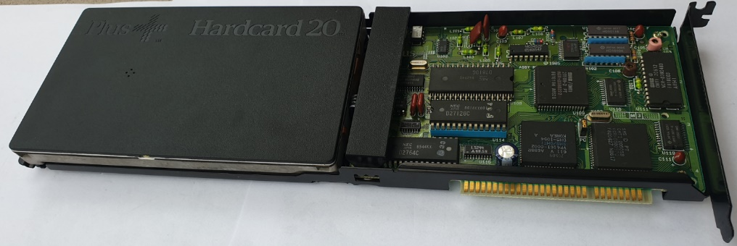

Size 2 ½”

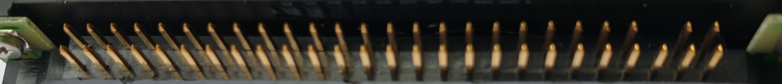
ESDI Enhanced Small Disk Interface.
Drive 2 ½” IBM WD-W2160D, h=17mm, 2x24 pins + 2x2 pins = 48+4 Σ=> 52 pins.
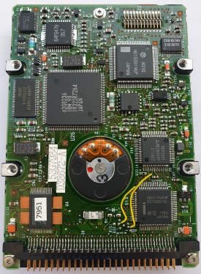
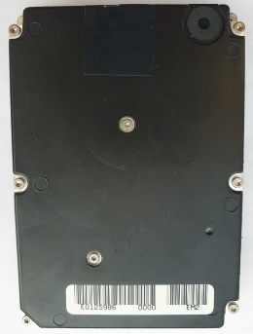
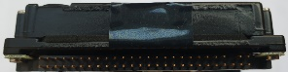

ESDI - caddy IBM WD-W2160D, h=18mm, case\caddy for the above-mentioned disk. 2x30 pins Σ=> 60 pins.

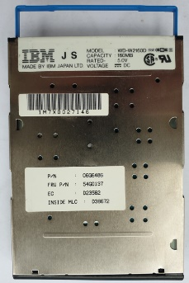
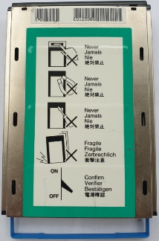
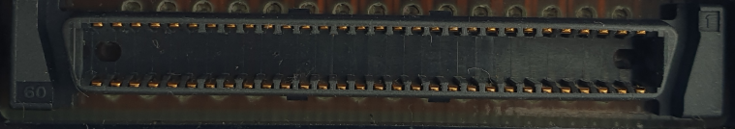
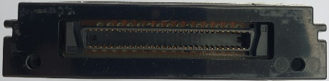
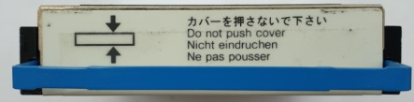
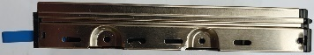
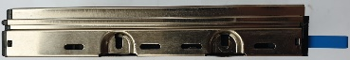

SCSI Apple (IBM)
Drive 2 ½” WDS-280 h=17mm, 2x20 pins + 2x4 pins Σ=> 48 pins.

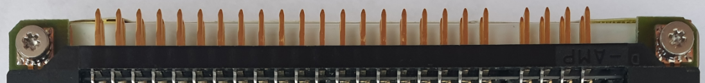
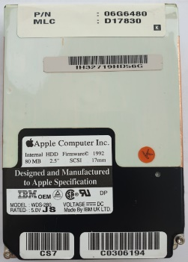
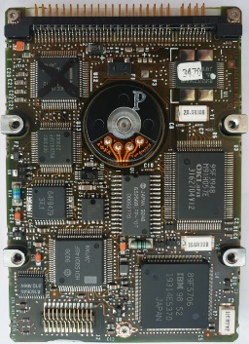
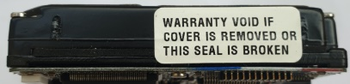

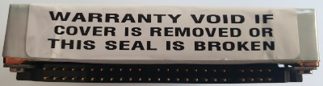

IDE thick
TOSHIBA MK2720FC h=18.5mm, 2x22 pins + 2x2 pins Σ=> 48 pins.

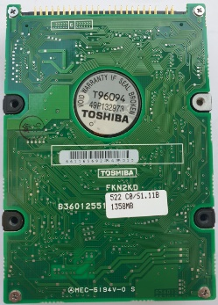
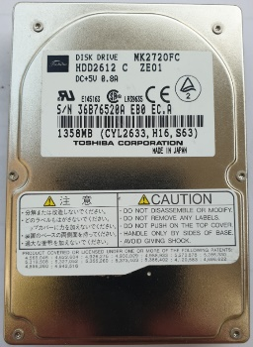
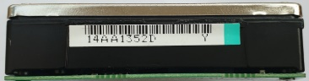

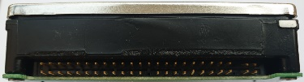

IDE
H=9.5mm. 2x22 pins + 2x2 pins Σ=> 48 pins.

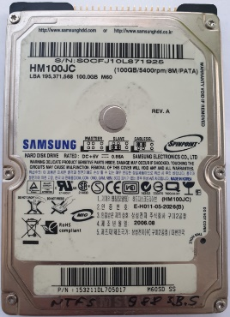
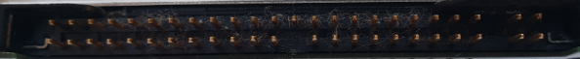
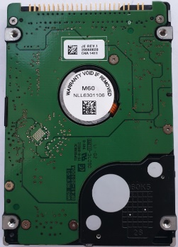

IDE. Half length. Thickness h=9.5mm. 2x22 pins + 2x2 pins Σ=> 48 pins.

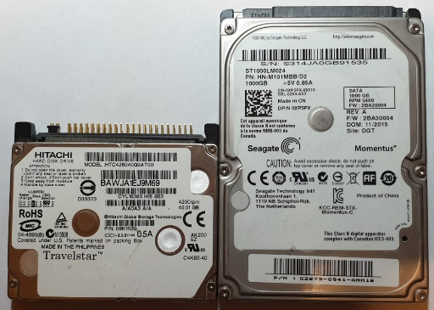
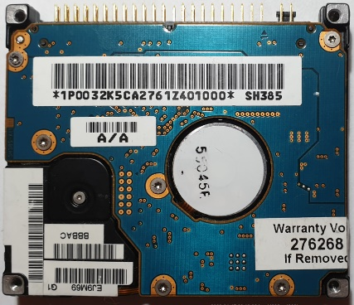
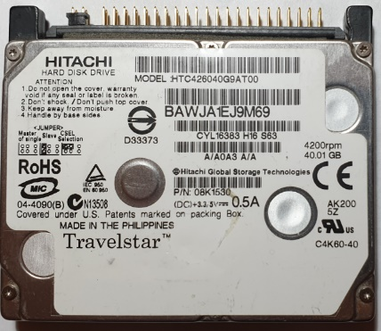
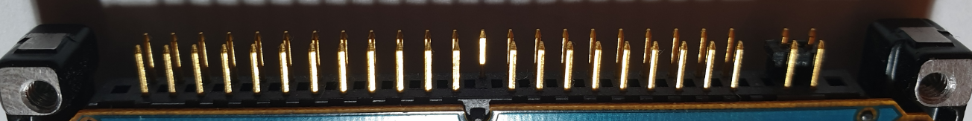

SCSI U320. ST936701LC. h=14.5mm. 2x40 pins. Σ=> 80 pins.
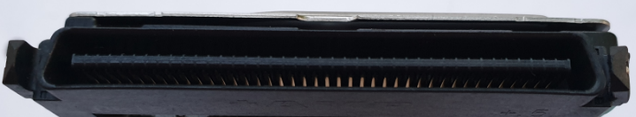

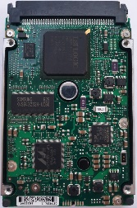
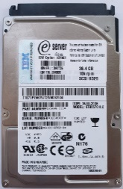
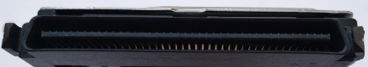

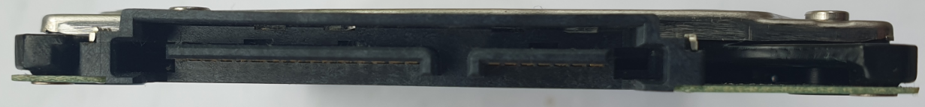
SATA. Hitachi. Thickness h=7mm. Pins 15+7. Σ=> 22 pins.
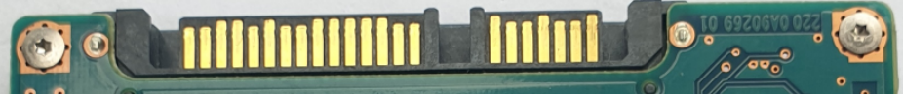

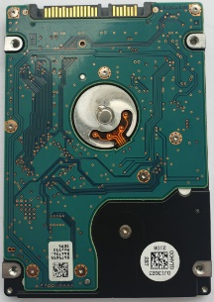
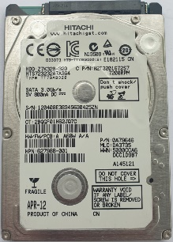

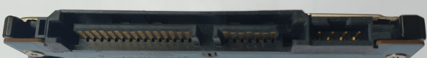
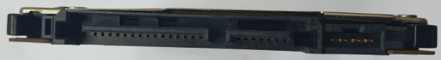
SATA. SSHD. Hitachi. Thickness h=7mm. Pins 15+7. Σ=> 22 pins.
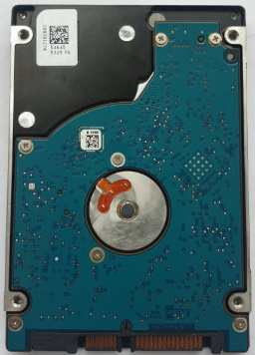
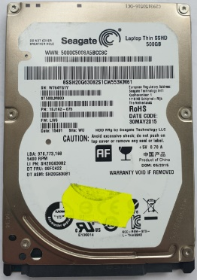

SATA. SSD. Intel. Thickness h=7mm. Pins 15+7. Σ=> 22 pins.
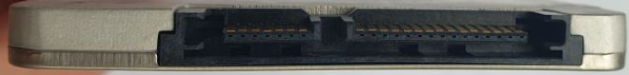
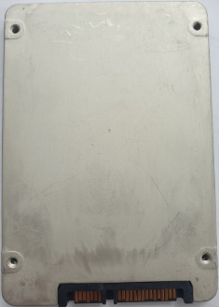
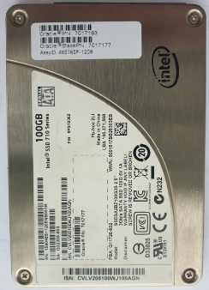

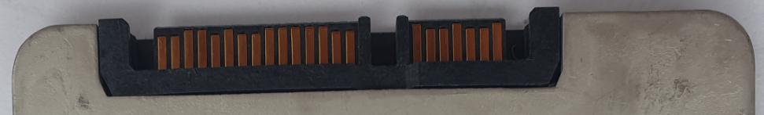

SATA. SSSE Samsung Solid State Enterprise - Hybrid. Intel. Thickness h=9.5mm.
Pins 15+7. Σ=> 22 pins.
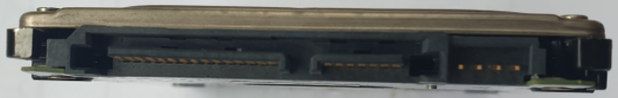

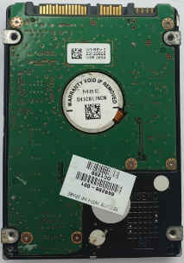
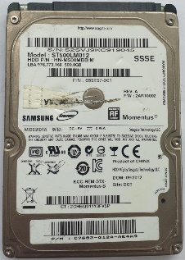

SATA. 8MB buffer. Toshiba. Thickness h=9.5mm. Pins 15+7. Σ=> 22 pins.
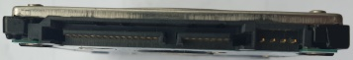

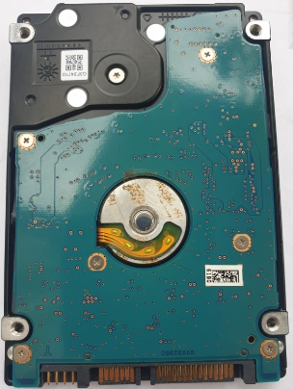
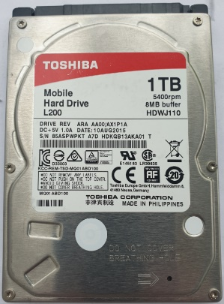

SATA. Toshiba. Thickness h=14.5mm. Pins 15+7. Σ=> 22 pins.
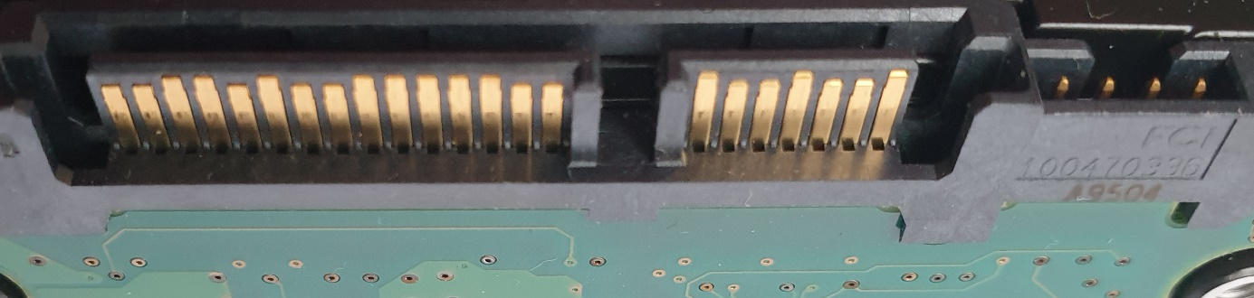

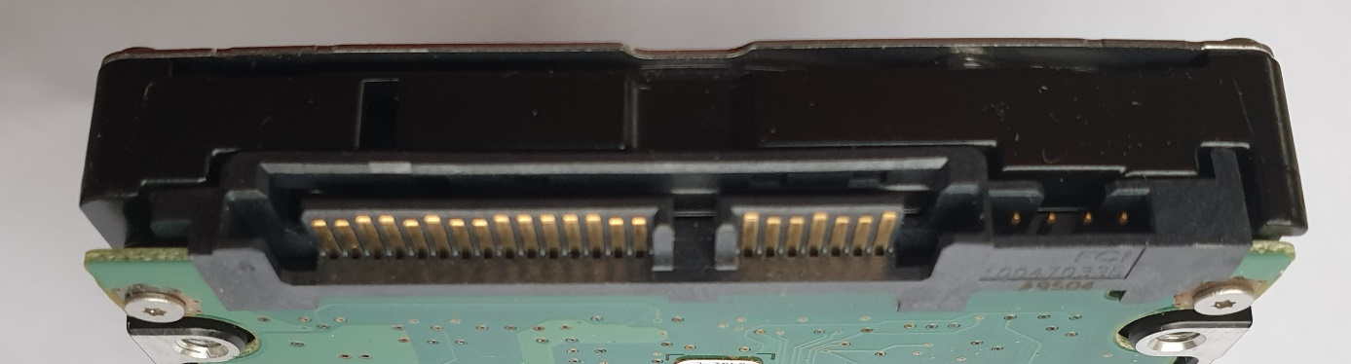

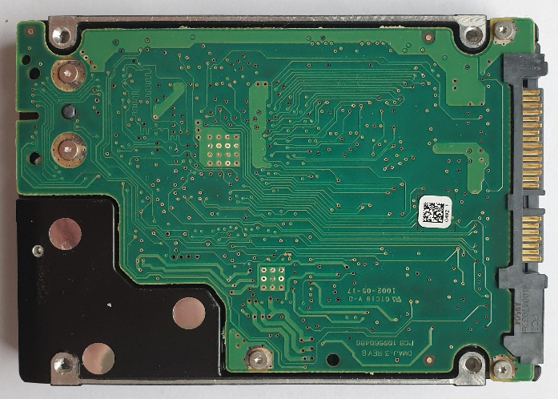
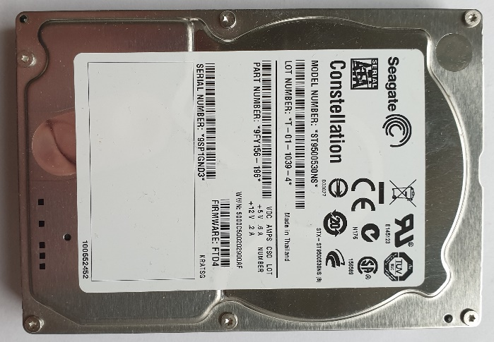

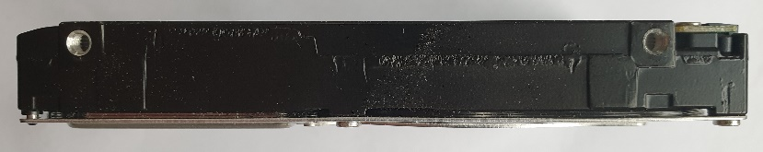

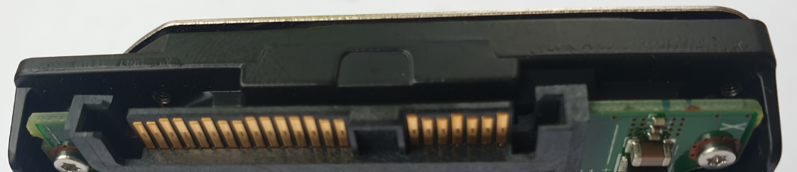
SAS. Sun\Fujitsu. Thickness h=14.5mm. Pins 15+7. Σ=> 22 pins.
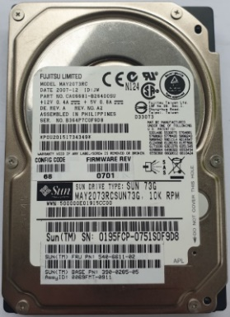
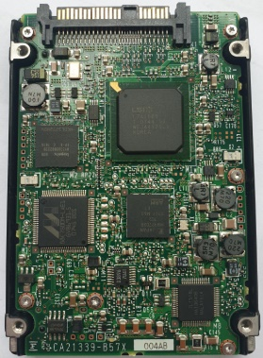
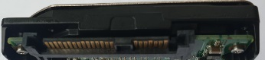

USB. Western Digital. Thickness h=14.5mm. Pins 5+4+6. Σ=> 15 pins.
White LED.

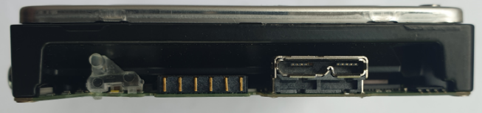

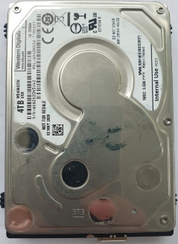
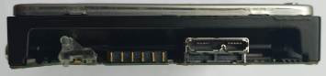
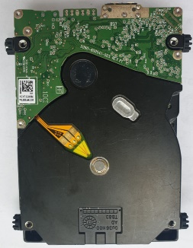

SATA. RDX IBM.

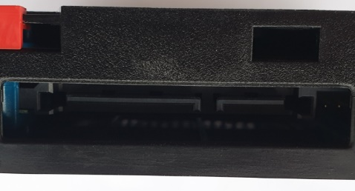

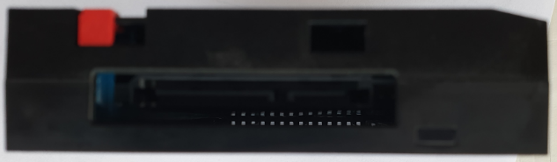

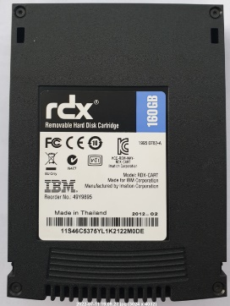
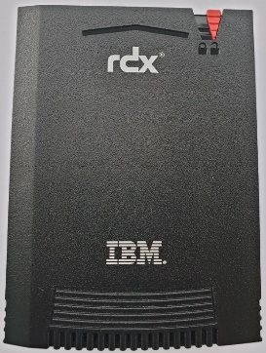
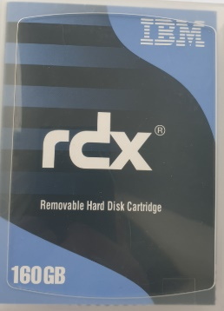
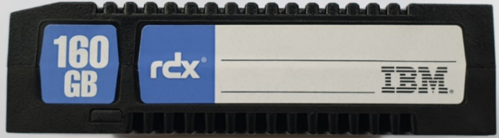
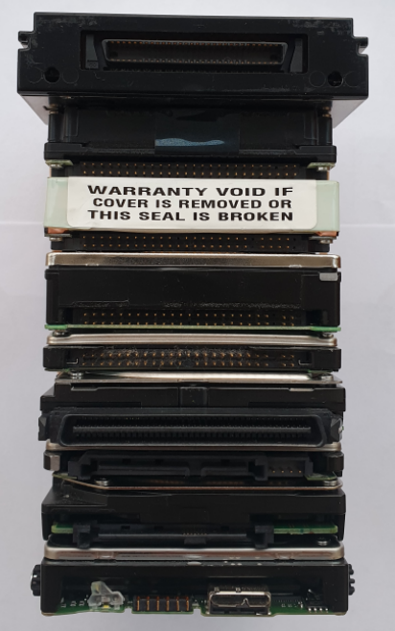

<- caddy do n\w HDD ESDI

<- ESDI

<- SCSI

<- IDE Toshiba GRUBY

<- IDE „zwykły”

<- SCSI U320

<- SATA

<- SAS

<- USB

SIZE 1.8”

HDD 1.8” PCMCIA CF+ Typ II 340MB 3600 rpm IBM. PN: 22L0046, Pin 2x25. Σ=> 50 pins.

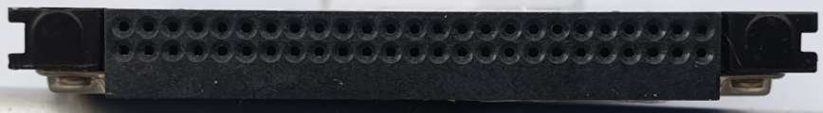
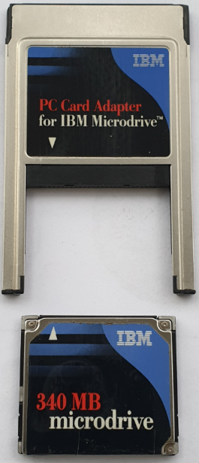
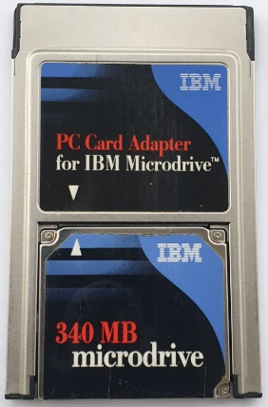
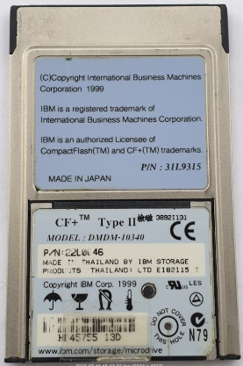

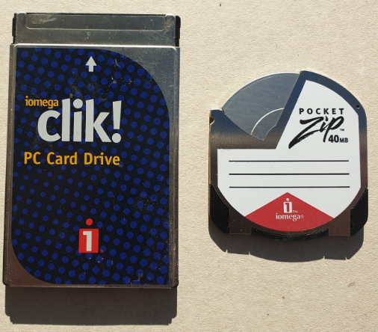
HDD 1.8” PCMCIA iOmega Clik! ZIP 40MB and HDD microdrive PCMCIA Typ I.
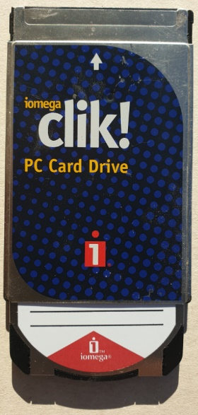

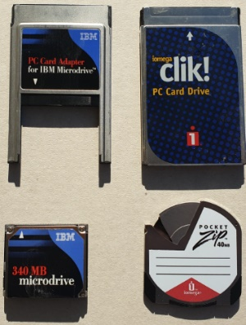
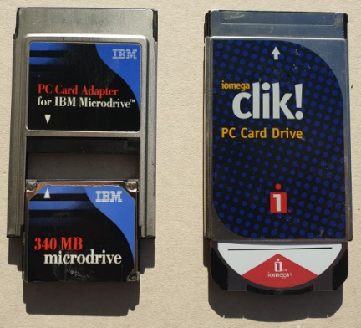
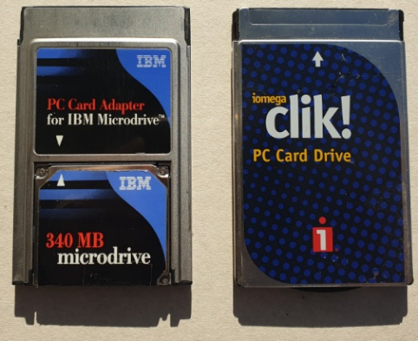

PCMCIA it is short from Personal Computer Memory Card International Association
Type I: 16-bit. Configuration thickness: 3.3 mm (0.13 in).
Type II: 16-bit or 32-bit. Configuration thickness: 5.0 mm (0.20 in).
Type III: 16-bit or 32-bit. Configuration thickness: 10.5 mm (0.41 in).
Type IV: 16 millimeters (0.63 in).

HDD 1.8” PCMCIA IBM 2x34. Σ=> 68 pins. PCMCIA Typ IV.
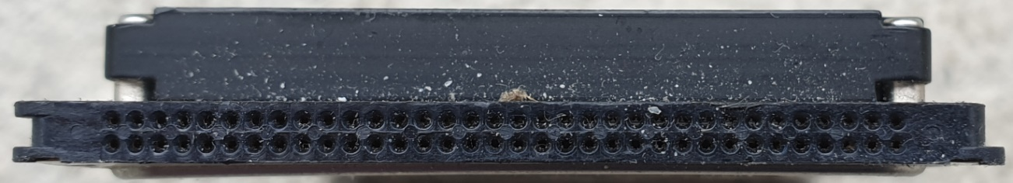
Height 16 mm.
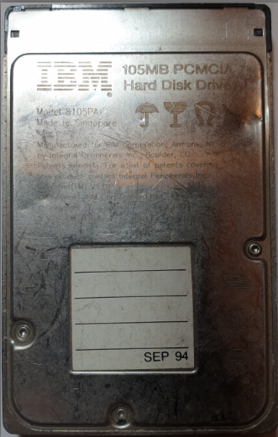
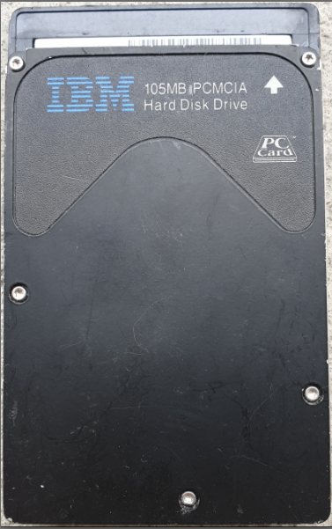

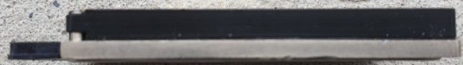

HDD 1.8” Toshiba PATA 2x25. Σ=> 50 pins.
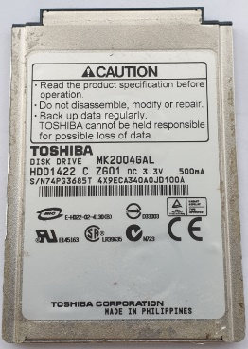
Height 8 mm

HDD 1.8” Toshiba mSATA 7+7+2. Σ=> 16 pins.
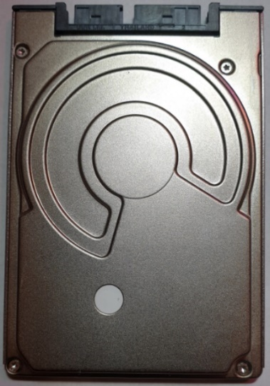
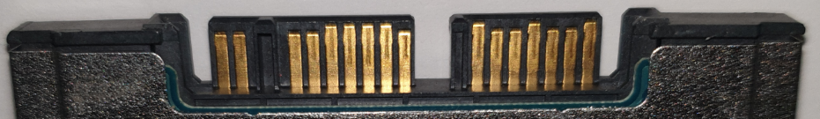
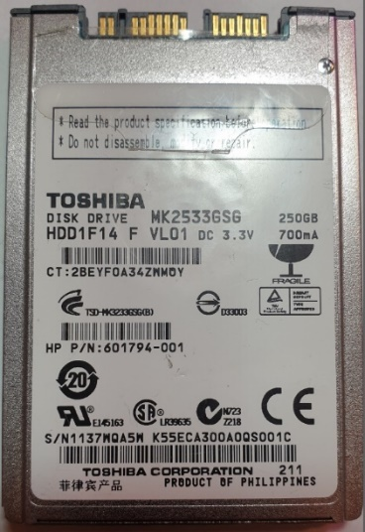

HDD 1.8” Apacer SLC HALF (half the length) Slim SATA 15+7. Σ=> 22 pins.
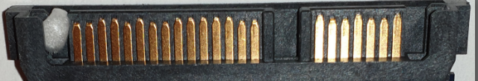

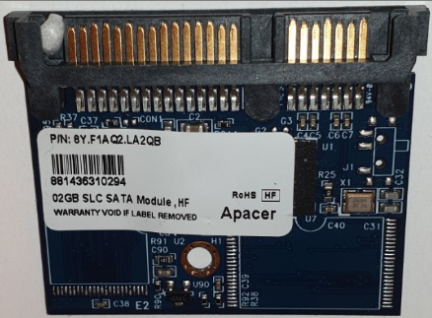

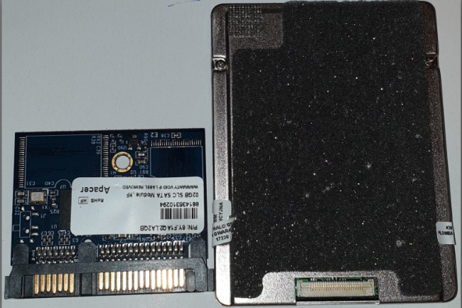

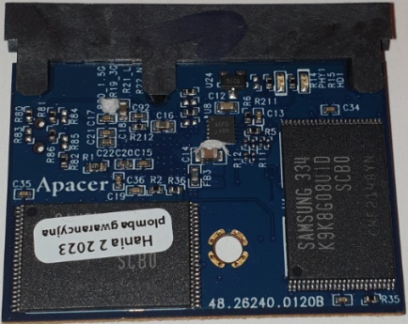

HDD 1.8” Toshiba PATA ZIF. Σ=> 40 pins.
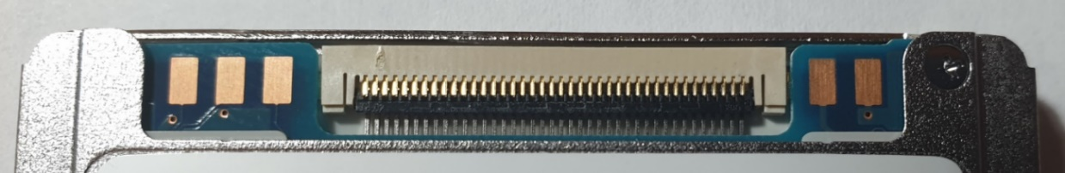
Height 8 mm.

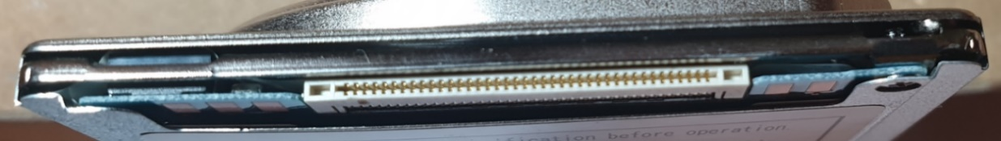

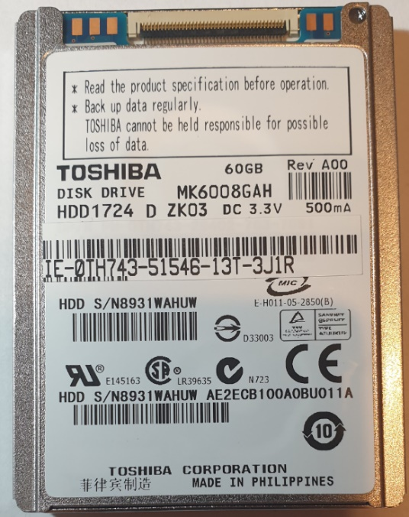

HDD 1.8” Samsung SSD LIF SATA. 2x24 Σ=> 48 pins.
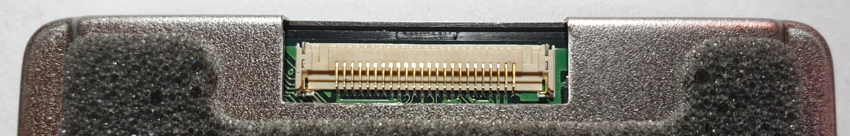
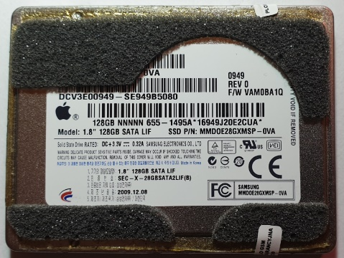
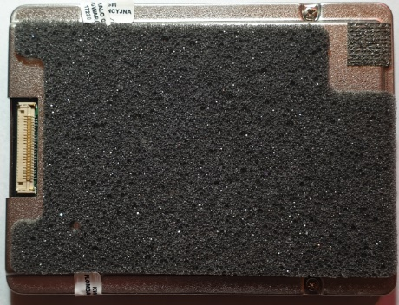

SIZE 1.3”

HDD 1.7” KityHawk HP\Citizen, IDE. Pins 2x25 Σ=> 50 pins.

Introduced by HP, manufactured by Citizen Corporation.
C3013A 20MB to HP Kittyhawk I.
C3014A 40MB to HP Kittyhawk II.

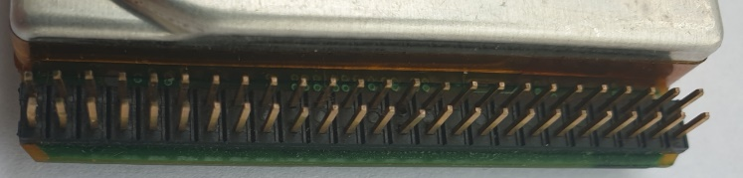
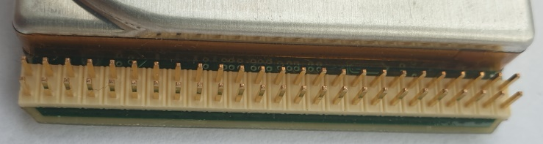
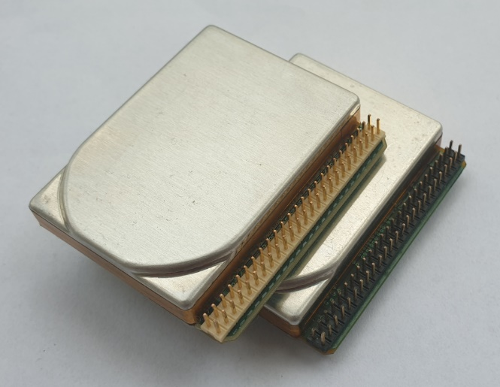

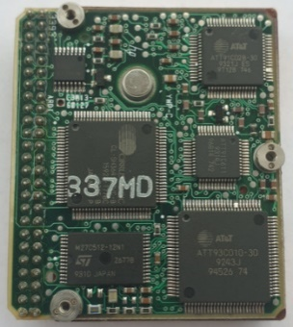
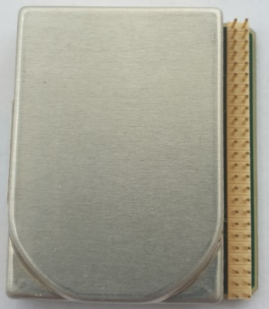
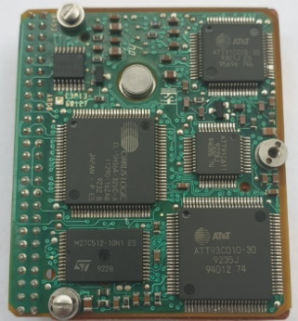
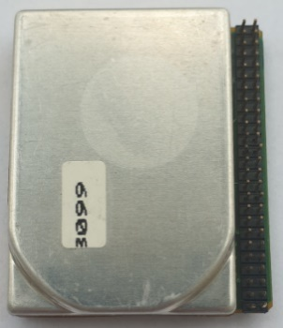

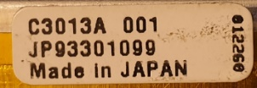
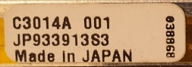

C3013A 20MB to HP Kittyhawk I C3014A 40MB to HP Kittyhawk II.

SIZE 1”

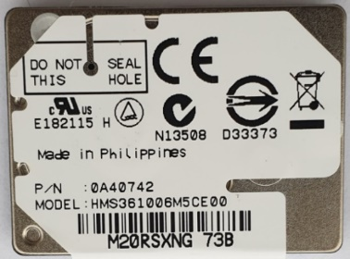
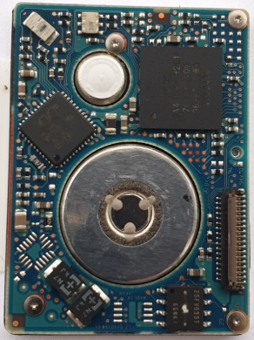
HDD 1” Hitachi.
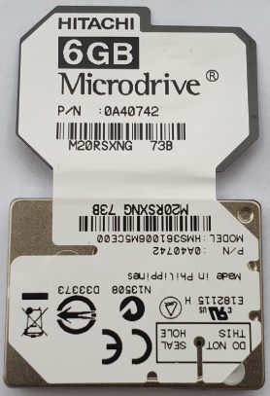

SIZE 0.85”

HDD 0.85” Toshiba from Nokia N91.
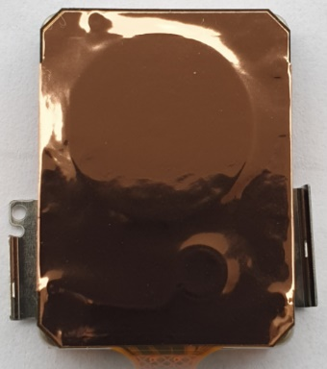
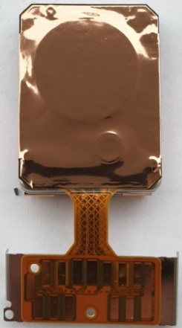
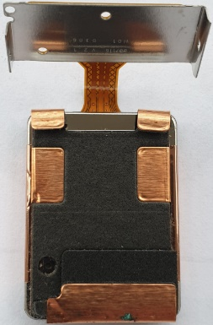

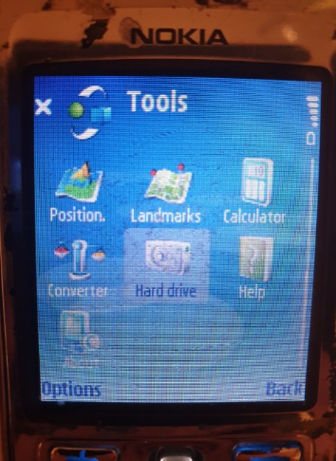
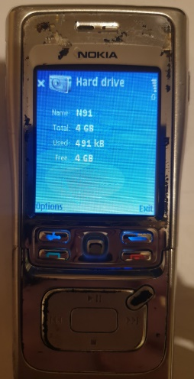

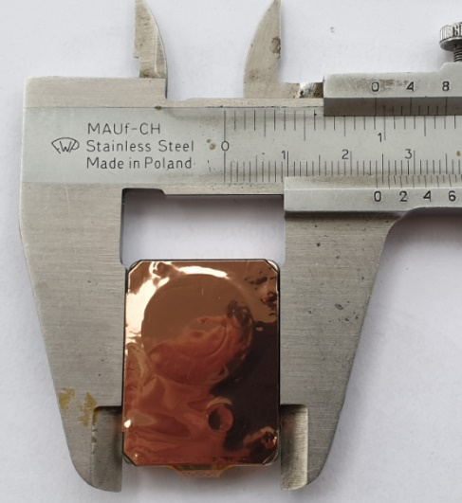

Różnice między interfejsami ST412 i ST506:
Szybkość transferu danych:
- ST412: 5 Mb/s
- ST506: 10 Mb/s
Kodowanie danych:
- ST412: MFM (Modified Frequency Modulation)
- ST506: MFM (Modified Frequency Modulation)
Pojemność dysku:
- ST412: Maksymalnie 20 MB
- ST506: Maksymalnie 40 MB
Złącze:
- ST412: 20-pinowe
- ST506: 34-pinowe

Złącza w interfejsach ST412 i ST506 służą zarówno do sterowania, jak i do transferu danych.
Złącze 20-pinowe w interfejsie ST412:
- Pin 1-10: Transfer danych
- Pin 11-16: Sterowanie
- Pin 17-20: Zasilanie
Złącze 34-pinowe w interfejsie ST506:
- Pin 1-20: Transfer danych
- Pin 21-30: Sterowanie
- Pin 31-34: Zasilanie
Dodatkowe piny w złączu ST506 umożliwiają przesyłanie większej ilości danych i zapewniają lepszą kontrolę nad dyskiem twardym.
Dyski IBM WDL-330P używają interfejsu ESDI (Enhanced Small Device Interface). Interfejs ESDI jest następcą interfejsu ST506 i oferuje kilka kluczowych zalet:
- Wyższa przepustowość: ESDI może przesyłać dane z prędkością do 10 Mb/s, podczas gdy ST506 jest ograniczony do 5 Mb/s.
- Większa pojemność dysku: ESDI obsługuje dyski twarde o pojemności do 1 GB, podczas gdy ST506 obsługuje dyski o pojemności do 40 MB.
- Ulepszone zarządzanie błędami: ESDI posiada wbudowane funkcje sprawdzania i korekcji błędów, co zapewnia większą niezawodność danych.
Interfejs MFM nie jest obsługiwany przez dyski IBM WDL-330P.
Dodatkowe informacje:
- Dyski IBM WDL-330P to dyski twarde o wysokości 5,25 cala i pojemności 330 MB.
- Dyski te były popularne w komputerach klasy PC w latach 80.

